

**Requirement Specifications**

**For Fresher Academy Management System**

Version: 0.4

**Approval Page**

The endorsement on this document by authorized ‘s representative indicates …and FPT‟s agreement on the “Requirement Specifications” document.

| **Prepared by:** | BA Practical team | Signature: | ____________________ |
| --- | --- | --- | --- |
|  |  | Date: | 07 April 2023 |
|  |  |  |  |
|  |  |  |  |
| **Reviewed by:** | xxxxx  Project Manager | Signature: | ____________________ |
|  |  | Date: | 26 April 2023 |
|  |  |  |  |
|  |  |  |  |
| **Approved by:** | (Customer Name) | Signature: | ____________________ |
|  |  | Date: | ____ /____ / ____ |

**Revision History**

| **Date** | **Version** | **Author** | **Change Description** |
| --- | --- | --- | --- |
| 03.07.2023 | 0.0.1 |  | Create document |
| 18.04.2024 | 0.0.4 |  | Update document |

Table of Contents

1. Introduction 3

1.1. Purpose 3

1.2. Overview 3

1.3. Scope of Work 4

1.4. Out of Scope 4

1.4.1. Active/de-active an account 4

1.4.2. Approve/reject syllabus 4

1.4.3. Approve/reject a training program 5

1.4.4. Delete a Syllabus 5

1.4.5. Delete a Training program 5

1.4.6. Manage Attendee list, Budget & Others of Class 5

1.5. Intended Audience 5

1.6. Constraints 6

1.7. Abbreviations 6

1.8. References 6

2. High Level Requirements 8

2.1. Data model 8

2.1.1. Conceptual data model 9

2.1.2. Logical data model 9

2.2. Use Case Diagram 10

2.3. User Story List 12

2.4. Permission Matrix 16

2.4.1. Super Admin 17

2.4.2. Class Admin 17

2.4.3. Trainer 18

2.4.4. Permission type 18

2.5. State Transition diagram 19

2.6. Site Map 20

3. User Story Specifications 21

3.1. User management 21

3.1.1. View list of existed user / User listing screen 21

3.1.2. Create user 26

3.1.3. Update user 29

3.1.4. Grant permission to user account 33

3.1.5. View permission 35

3.1.6. Update role permission 38

3.2. Management syllabus 41

3.2.1. View list of existed syllabus/ Syllabus listing screen 42

3.2.2. Create Syllabus (General Tab) 48

3.2.3. Create Syllabus (Outline Screen) 55

3.2.4. Create Syllabus (Other Screen) 66

3.2.5. Read syllabus information/Syllabus detail information screen (Admin) 70

3.2.6. Read syllabus information/Syllabus detail information screen (Instructor) 80

3.2.7. Update/edit syllabus information 81

3.2.8. Import syllabus/ syllabus importing screen 82

3.2.9. Duplicate syllabus 87

3.2.10. Search syllabus 87

3.3. Management training program 88

3.3.1. View list of existed training program/ Training program listing screen 88

3.3.2. Create Training program 94

3.3.3. View detail Training Program 102

3.3.4. Update training program information 105

3.3.5. Import training program/ training program importing screen 107

3.3.6. Duplicate training program 111

3.3.7. Active/Deactive training program 112

3.3.8. Search training program 113

3.3.9. Upload training materials 116

3.3.10. Delete training materials 119

3.3.11. Download training materials 120

3.4. Class management 121

3.4.1. Search class on list 121

3.4.2. View list of class 126

3.4.3. Create class 129

3.4.4. View class details 138

3.4.8. Delete class 140

3.4.10. View training calendar 141

3.5. Error message 145

4. Other Function Specifications 163

4.1. Rule for syllabus version 164

4.2. Rule for Training Program Version 164

5. Other requirements 165

5.1. Common field controls 165

5.1.1. Free text (Single line of text) 165

5.1.2. Option Set 165

5.1.3. Special Text 165

5.1.4. Search bar 166

5.1.5. Drop-down list 167

5.1.6. Image attachment 167

5.1.7. Rich text 168

5.1.8. Date picker 169

5.1.9. Label Display 169

5.1.10. Message configuration 169

5.1.11. View columns display 169

5.1.12. Pagination 170

# Introduction

## Purpose

The Functional Requirements Specification will:

* Define the scope of business objectives, business functions, and organizational units covered.
* Identify the business processes that the solution must facilitate.
* Facilitate a common understanding of what the functional requirements are for all parties involved.
* Establish a basis for defining the acceptance tests for the solution to confirm that what is delivered meets requirements.

The purpose of the document is to collect and analyse all assorted ideas that have come up to define the system, its requirements with respect to consumers. Also, we shall predict and sort out how we hope this product will be used in order to gain a better understanding of the project, outline concepts that may be developed later, and document ideas that are being considered, but may be discarded as the product develops.

## Overview

The Fresher Academy Management System (FAMS) is a comprehensive software solution designed to efficiently manage and streamline the operations of a fresher academy of FPT. FAMS encompasses a range of features including user management, syllabus management, and training program and class management. This Functional Requirements Specification (FRS) document outlines the key functionalities and requirements of FAMS, providing a clear understanding of its purpose, scope, and limitations.

## Scope of Work

The expectation for FAMS in this current release is described in Use Case Diagram and User Story list. The in-scope details are:

* User management: FAMS allows administrators to manage user accounts, including trainers, class admin, and general admin, by providing functionalities such as account creation, access control, and user profile management.
* Syllabus management: FAMS enables the management and organization of syllabus for various courses and training programs. It provides functionalities to create, update, and maintain syllabus, ensuring accurate and up-to-date information is readily available.
* Training program: FAMS facilitates the planning, scheduling, and coordination of training programs. It allows administrators to define program details, allocate trainers, set program durations, and assign syllabus to programs
* Class management: FAMS provides tools and features to create and manage individual classes within training programs. This includes defining and updating class schedules, assigning trainers.

## Out of Scope

Other functions and goals that are not included in scope of work or limited in this Specification and these mentioned below:

### 

### Approve/reject syllabus

* The system provides administrators and authorized personnel the ability to review and approve/reject syllabus for various courses offered by the academy.
* Upon submission, syllabus undergo a review process to ensure they meet the predefined quality standards and align with the academy's curriculum objectives.
* Approved syllabuses are made available to instructors and students, allowing for effective course delivery and learning.
* Rejected syllabus prompt the necessary revisions by instructors, ensuring the content meets the required criteria before approval.
* This functionality facilitates centralized control over course content and maintains the consistency and quality of educational materials.

### Approve/reject a training program

* The system empowers administrators and designated personnel to review and approve/reject training programs or courses offered by the academy.
* Upon submission, training programs undergo an evaluation process to assess their relevance, quality, and alignment with the academy's objectives.
* Approved training programs are made accessible to students, enabling them to enrol and participate in the desired courses.
* Rejected training programs prompt necessary adjustments by program organizers to meet the required criteria for approval.
* This feature ensures that only validated and valuable training programs are offered, maintaining the academy's reputation for delivering high-quality education.

### 1.5.3. Manage Attendee list, Result, Budget & Others of Class

* This feature needs to be defined clearer about business need, business requirement & functional requirement.
* For example:
* Admin can manage the score of each module, each trainee, evaluation result, attendance status such as dropout, send email about evaluation, …
* Class can be updated in which status and by whom...

### 1.5.4. Advanced search for Syllabus/Training program

* This feature needs to be defined clearer about business need, business requirement & functional requirement.

## Intended Audience

This document is intended for:

* Development team: Responsible to develop detailed design, implement and perform unit test, integration test and system test for the migrated application
* Documentation Team: Responsible to write User Guide for the application.
* UAT team: Responsible to conduct user acceptance test sessions with end users.

## Constraints

The project being a part of a short-term training program may lead to limitations and missing minor parts in the product. The constrained timeframe may result in reduced effort and fragmented attention due to the simultaneous demands of the training program. This can impact the thoroughness of certain aspects, such as extensive testing or additional features. Additionally, resource constraints, including limited personnel or time allocation, may affect the overall product completeness and depth. Despite these limitations, the project will aim to deliver the core functionalities and prioritize the essential components to ensure a viable and usable product within the given training program duration.

## Abbreviations

| **Acronym** | **Reference** |
| --- | --- |
| FAMS | Fresher Academy Management System |
| FA | Fresher Academy |
| US | User Story |
| AC | Acceptance Criteria |
| FRS | Function Requirement Specification |
| UI | User interfaces |
| DOB | Date of birth |
| URL | Uniform Resource Locator |
| N/A | Not applicable |
| ID | Identification |
| UAT | User acceptance testing |
| EM | Error message |

## References

| **No** | **Tittle** | **Author** | **Version** | **Date** | **Source/****Location** |
| --- | --- | --- | --- | --- | --- |
| 1 | Fresher Academy – FA Management  Requirement Specification  For FA Management | (FPT) Trinh Hong Nhung  Business Analyst | 0.8.8 | 29/09/2020 | [FA_System Requirement Specification_ver 0.8.8.docx](https://fptsoftware362.sharepoint.com/:w:/r/sites/FAMS_BAPRACTICALCOURSE/Shared%20Documents/FAMS%20QnA/Reference%20document/FA_System%20Requirement%20Specification_ver%200.8.8.docx?d=w3a503215c29c4c0294f2d91d7ba0aacb&csf=1&web=1&e=AX9Xc8) |
| 2 | FAMS mind map | (FPT) Dinh Vu Quoc Trung | 1.0 | 31/05/2023 | [FAMS.xmind](https://fptsoftware362.sharepoint.com/:u:/r/sites/FAMS_BAPRACTICALCOURSE/Shared%20Documents/FAMS%20QnA/Reference%20document/FAMS.xmind?csf=1&web=1&e=XkhepH) |
| 3 | Template Import MockSyllabus | FAMS team | 1.2 | 24/03/202 | [Template_Import_MockSyllabus.xlsx](https://fptsoftware362.sharepoint.com/:x:/r/sites/FAMS_BAPRACTICALCOURSE/Shared%20Documents/FAMS%20QnA/Reference%20document/Template_Import_MockSyllabus.xlsx?d=w60c0db58838d4190a53e1eea3e833647&csf=1&web=1&e=Qi6a51) |
| 4 | Template Import Syllabus | FAMS team | 1.2 | 24/04/202 | [Template_Import_Syllabus.xlsx](https://fptsoftware362.sharepoint.com/:x:/r/sites/FAMS_BAPRACTICALCOURSE/Shared%20Documents/FAMS%20QnA/Reference%20document/Template_Import_Syllabus.xlsx?d=w9cdc32baa3c64ef68d3e3f52752669e8&csf=1&web=1&e=ioc9vg) |
| 5 | FA training system diagram | (FPT) Dinh Vu Quoc Trung | 1.0 | 31/05/2023 | [FA_training_system_260822-BA_PRAC_class.fig](https://fptsoftware362.sharepoint.com/:u:/r/sites/FAMS_BAPRACTICALCOURSE/Shared%20Documents/FAMS%20QnA/Reference%20document/FA_training_system_260822-BA_PRAC_class.fig?csf=1&web=1&e=madnbC) |
| 6 | Training management system (Reviewed version) | BA practical team | 1.0 | 26/08/2022 | [SRS_FA TRAINING MANAGEMENT SYSTEM_v1.0_TrungDVQ_Reviewing_3.1.4.docx](https://fptsoftware362.sharepoint.com/:w:/r/sites/FAMS_BAPRACTICALCOURSE/Shared%20Documents/FAMS%20QnA/Reference%20document/SRS_FA%20TRAINING%20MANAGEMENT%20SYSTEM_v1.0_TrungDVQ_Reviewing_3.1.4.docx?d=w7ffd9febacf74e119ec696e61a3097f4&csf=1&web=1&e=XdkXJJ) |
| 7 | FAMS Figma design | BA practical team 2022 | 1.5 | 26/05/2023 | [FAMS Figma UI_2022](https://www.figma.com/file/oLiZWOPMCQtDJfKFZhafYD/FAM_Practical-BA-2023?type=design&node-id=295-5993&mode=design&t=PKqdYWsVWvyWPQTK-0) |
| 8 | FAMS Figma design | BA practical team 2023 | 1.0 | 10/07/2023 | [FAMS Figma UI_2023](https://www.figma.com/file/6tLNpYrNQwpAr7f4PfRua5/Practical-BA-2023_FAM?type=design&node-id=1-2&mode=design&t=qKqGUk3tajcEiBgc-0) |

# High Level Requirements

This section describes the general overview of the system functions or business processes which are depicted in different diagrams. It shows the types of users, their granted permissions to perform specific system functions and the sequence required to complete a business workflow. For detailed requirement specification, please see the section below.

## Data model

The data model diagram visually represents the structure, attributes, and relationships between data entities in a system.

### Conceptual data model

The conceptual data model diagram provides a high-level overview of the data entities and their relationships within a system.

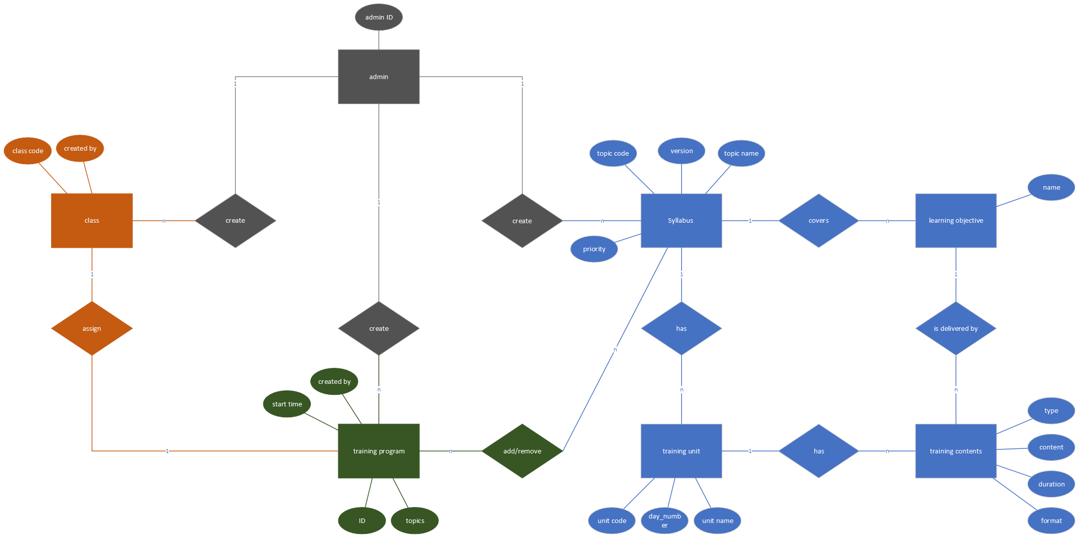

*Figure 1: Conceptual data model*

### Logical data model

The logical data model represents the structure and organization of data entities, their attributes, and the relationships between them at a more detailed and refined level compared to the conceptual data model. This data model would give the development team guidance but not limited as the must to be in building an effective database.

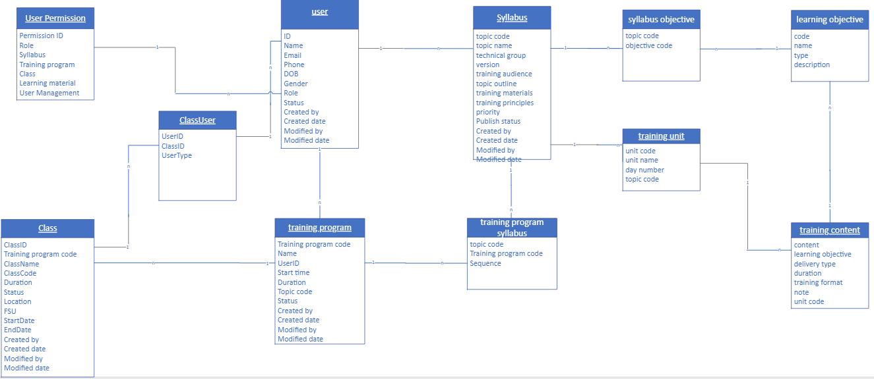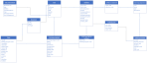

*Figure 2: Logical data model*

## Use Case Diagram

These are the goals of the user when interacting with the FAMS.

https://drive.google.com/file/d/1dgsbYeJAl9mEZrZMNUbzZ0H31k2issXK/view

## User Story List

The project is run by Agile method which means being implemented with Epics and User Stories. Those Epics and User Stories below represent for the user’s intent to accomplish in FAMS:

| **No.** | **Function** | **User Stories** | **Description** |
| --- | --- | --- | --- |
| **Epic: User management** | | | |
| 1 | View list of existed user / User listing screen | As an admin, I want to be able to view a list of existing user order by name, so that I can manage all user and I can easily find and update their current information. | Allow admin to view list of existed user / User listing screen |
| 2 | Create user | As an Admin, I want to create a user account, so that user can access to FAM system | Allow admin to create a user |
| 3 | Update user | As an Admin, I want to update user details, so that user has the latest information | Allow admin to update user detail (user information) |
| 4 | Grant permission to user account | As a Super Admin, I want to add permission to user account, so that user will have a specific permission by their roles | Allow super admin to add permission to user account |
| 5 | View permission matrix | As an Admin, I want to view permission matrix, so that I can know the specific permission of each role | Allow admin to view permission matrix screen |
| 6 | Update permission to user | As an Admin, I want to update permission to user account, so that all user with the same permission can be updated | Allow admin to update permission to user |
| **Epic Syllabus Management** | | | |
| 7 | View list of existed syllabus / Syllabus listing screen | As an admin/instructor, I want to be able to view a list of existing syllabus order by **created_date**, so that I can overview all syllabus from the newest to the oldest and I can easily find and update current syllabuses. | Allow admin/instructor to view list of existed syllabus / Syllabus listing screen |
| 8 | Create syllabus general screen | As an admin/instructor, I want to fill the syllabus general information on a separate screen, so that I can fulfill all general information before going to next step of creating syllabus | Allow admin/instructor to fill the syllabus general information |
| 9 | Create syllabus outline screen | As an admin/instructor, I want to fill the syllabus outline information on a separate screen, so that I can fulfill all general information before going to next step of creating syllabus | Allow admin/instructor to fill the syllabus outline information |
| 10 | Create syllabus other screen | As an admin/instructor, I want to fill the syllabus outline information on a separate screen, so that I can fulfill all general information before going to next step of creating syllabus | Allow admin/instructor to fill the syllabus outline information |
| 11 | Read syllabus information/Syllabus detail information screen | As an admin, I want to be able to read all detail information of the syllabus, so that I can understand what syllabus is talking about and answer trainee if they have question. | Allow admin/instructor to read all detail information of the syllabus |
| 12 | As an instructor, I want to be able to read all detail information of the syllabus, so that I will have detail information of the syllabus to prepare for lecture content in class. |
| 13 | Update/edit syllabus information | As an admin/instructor, I want to be able to update information of existed syllabus, so that I can update the newest and exact information of the syllabus | Allow admin/instructor to update information of existed syllabus |
| 14 | Import syllabus/ syllabus importing screen | As an admin, I want to be able to create a new syllabus through importing CSV/excel file, so that I can save my time to ingest one existed syllabus by CSV/excel file without filling every fields in manually | Allow admin to create a new syllabus through importing CSV/excel file |
| 15 | Duplicate syllabus | As an instructor, I want to be able to create a new syllabus version by cloning the existed one, so that I can quickly create a syllabus for the training program and update some of the syllabus content if needed but not cause changes to the original one. | Allow instructor to create a new syllabus version by cloning the existed one |
| 16 | Search syllabus | As an admin/instructor, I want to view a list of syllabuses filter by searching condition, so that I can shorten the list of information for finding purpose | Allow admin/instructor to view a list of syllabuses filter by searching condition |
| **Epic: Training program** | | | |
| 17 | View Training Program list | As an Admin, I want to be able to view a Training Program list, so that I can know and manage all the existing training program | Allow admin to view a Training Program list |
| 18 | Create a training Program | As an Admin, I want to be able to create a new training program, so that I can input/store important information and syllabuses of the training program. | Allow Admin to create a new training program |
| 19 | View detail Training Program | As an Admin/ BU lead/ Trainer/ Trainee, I want to be able to view detail Training Program list, so that I can view detailed Information, detailed training Materials, included syllabus of the Training Program | Allow Admin/ BU lead/ Trainer/ Trainee to view detail Training Program list |
| 20 | Update Training Program | As an Admin, I want to be able to update a Training Program, so that I can adjust important information and syllabuses of the training program. | Allow Admin to update a Training Program |
| 21 | Import Training Program | As an Admin, I want to be able to import a new Training Program by upload a template, so that I can save time for creating a new training program | Allow Admin to import a new Training Program by upload a template |
| 22 | Duplicate Training Program | As an Admin, I want to be able to create a new Training Program by duplicating an existed one, so that I can save time for creating a new training program | Allow Admin to create a new Training Program by duplicating an existed one |
| 23 | Active/deactive training program | As an Admin, I want to be able to active/deactive a Training Program, so that I can control its availability for enrolment by trainees | Allow Admin to active/deactive a Training Program |
| 24 | Search training program | As an Admin, I want to able to search an existed training program by its name, so that I can finding specific training programs | Allow admin to search an existed training program |
| 25 | Upload Materials | As an Admin, I want to be able to upload external training materials into my training programs, so that I can provide a variety of learning resources to trainees | Allow Admin to upload external training materials into my training programs |
| 26 | Delete Materials | As an Admin, I want to be able to delete external training materials into my training programs, so that I can remove specific learning resources from training programs | Allow Admin to delete external training materials into my training programs |
| 27 | Download Materials | As an Admin, I want to be able to download a training material from training programs, so that I can view, save and check detail of materials | Allow Admin to download a training material from training programs |
| **Epic: Class management** | | | |
| 28 | Search class on list | As an Admin, I want to search on class list by Class code and class name, so that I can quickly find the information I need | Allow Admin to search on class list |
| 29 | View list of class | As an Admin, I want to view list of class, so that I can have an overview of all class records and access their details easily | Allow Admin to view list of class |
| 30 | Create class | As an Admin, I want to create a new class such as training program, list of candidates, trainer, list of syllabuses, so that I can run created class | Allow Admin to create a new class such as training program, list of candidates, trainer, list of syllabuses |
| 31 | View class detail | As an Admin, I want to view detail of class such as training program, list of candidates, trainer, list of syllabuses, so that I can review detail of this class | Allow Admin to view detail of class such as training program, list of candidates, trainer, list of syllabuses |
| 32 | Update class | As an Admin, I want to update class with these information training program, training schedule, list of candidates, trainer, list of syllabuses, so that I can change before it run | Allow Admin to update class with these information training program, training schedule, list of candidates, trainer, list of syllabuses |
| 33 | Update class | As an Admin, I want to change Training Program for class, so that I can choose another Training Program that is more suitable for class | Allow Admin to change Training Program for class |
| 34 | Update class | As an Admin, I want to modify list of syllabuses of class, so that I can change content of Training Program that is more suitable for class | Allow Admin to modify list of syllabuses of class |
| 35 | Deactivate class | As an Admin, I want to deactivate class on class list, so that the list will show all useable class | Allow Admin to deactivate class on class list |
| 36 | Search on Training Calendar | As an Admin, I want to search on training calendar, so that I can quickly find the information I need on schedule | Allow Admin to search on training calendar |
| 37 | View training calendar | As an Admin, I want to view schedule by each class via training calendar, so that I can have an overview schedule for specific class | Allow Admin to view schedule by each class via training calendar |
| 38 | Update training calendar | As an Admin, I want to update re-schedule class via training calendar screen, so that I can replan class schedule | Allow Admin to update re-schedule class via training calendar screen |

Các phần quản lý detail lớp thì chưa thấy nhỉ.

Ví dụ: Admin muốn nhập điểm các module cho trainee ==> chưa thấy. Phần này quan trọng.

Admin muốn gởi thông báo điểm cho từng học viên.

Admin muốn nắm thông tin về điểm của học viên. Các sếp loại của học viên.

Admin muốn set các status của học viên, note thông tin học viên. Ví dụ học viên dropout,

Admin quản lý điểm danh của học viên.

1. Introduction 3

1.1. Purpose 3

1.2. Overview 3

1.3. Scope of Work 4

1.4. Out of Scope 4

1.4.1. Active/de-active an account 4

1.4.2. Detail User role/User permission 4

1.4.3. Approve/reject syllabus 5

1.4.4. Approve/reject a training program 5

1.4.4. Delete a Syllabus 6

1.4.5. Delete a Training program 6

1.4.6. Manage Attendee list, Result, Budget & Others of Class 6

1.4.7. Advanced search for Syllabus/Training program 6

1.5. Intended Audience 6

1.6. Constraints 6

1.7. Abbreviations 7

1.8. References 7

2. High Level Requirements 9

2.1. Data model 9

2.1.1. Conceptual data model 10

2.1.2. Logical data model 10

2.2. Use Case Diagram 11

2.3. User Story List 13

2.4. Permission Matrix 18

2.4.1. Super Admin 18

2.4.2. Class Admin 18

2.4.3. Trainer 19

2.4.4. Permission type 19

2.5. State Transition diagram 20

2.6. Site Map 21

3. User Story Specifications 22

3.1. User management 22

3.1.1. View list of existed user / User listing screen 22

Screen item description 23

3.1.2. Create user 27

3.1.3. Update user 30

Screen item description 31

3.1.4. Grant permission to user account 34

Screen item description 35

3.1.5. View permission 36

Screen item description 36

3.1.6. Update role permission 39

3.2. Management syllabus 42

3.2.1. View list of existed syllabus/ Syllabus listing screen 43

Screen item description 43

3.2.2. Create Syllabus (General Tab) 49

Screen item description 51

3.2.3. Create Syllabus (Outline Screen) 56

Screen item description 57

3.2.4. Create Syllabus (Other Screen) 67

Screen item description 68

3.2.5. Read syllabus information/Syllabus detail information screen (Admin) 71

Screen item description (refer Create Syllabus (General/Outline/Others) – Figure 12, 13, and 14) 72

3.2.6. Read syllabus information/Syllabus detail information screen (Instructor) 81

Screen item description (Refer Figure 15, 16, and 17) 82

3.2.7. Update/edit syllabus information 82

Screen item description (Refer Figure 12, 13, and 14) 83

3.2.8. Import syllabus/ syllabus importing screen 83

Screen item description 84

3.2.9. Duplicate syllabus 87

Screen item description (Refer Figure 12) 88

3.2.10. Search syllabus 88

Screen item description (Refer Figure 13) 88

3.3. Management training program 89

3.3.1. View list of existed training program/ Training program listing screen 89

Screen item description 90

3.3.2. Create Training program 95

Screen item description (Figure 20, 21, and 22) 95

3.3.3. View detail Training Program 104

Screen item description (Refer Figure 16, 21, 22, and 30) 104

3.3.4. Update training program information 106

Screen item description (Refer Figure 22) 107

3.3.5. Import training program/ training program importing screen 108

Screen item description 108

3.3.6. Duplicate training program 112

Screen item description (Refer Figure 22) 113

3.3.7. Active/Deactive training program 113

Screen item description (Refer Figure 19) 114

3.3.8. Search training program 114

Screen item description 115

3.3.9. Upload training materials 117

Screen item description 118

3.3.10. Delete training materials 120

Screen item description (Refer figure 27) 121

3.3.11. Download training materials 121

Screen item description (Refer figure 27) 122

3.4. Class management 122

3.4.1. Search class on list 122

Screen item description 123

3.4.2. View list of class 127

Screen item description 128

3.4.3. Create class 130

Screen item description 131

3.4.4. View class details 139

Screen item description 140

3.4.5. Update class01 142

Screen item description 143

3.4.6. Update class02 145

Screen item description 145

3.4.7. Update class03 146

Screen item description 147

3.4.8. Deactivate class 148

Screen item description 149

3.4.9. Search on training calendar 150

Screen item description 151

3.4.10. View training calendar 154

Screen item description 155

3.4.11. Update training calendar 159

Screen item description 160

3.5. Error message 162

4. Other Function Specifications 164

4.1. Rule for syllabus version 165

4.2. Rule for Training Program Version 165

5. Other requirements 166

5.1. Common field controls 166

5.1.1. Free text (Single line of text) 166

5.1.2. Option Set 166

5.1.3. Special Text 166

5.1.4. Search bar 167

5.1.5. Drop-down list 168

5.1.6. Image attachment 168

5.1.7. Rich text 169

5.1.8. Date picker 170

5.1.9. Label Display 170

5.1.10. Message configuration 170

5.1.11. View columns display 170

5.1.12. Pagination 171

## Permission Matrix

Due to the function to modify a permission group which reflects to the permission of user in FAMS, this matrix below is just the recommendation. User with these assigned permissions should be able to act as the default of FAMS:

Remark:

“Y” means that user has permission on corresponding function. For more information about what the actor can

“N” means that user does not have permission on corresponding function.

“n/a” means there is no permission on that function.

### Super Admin

| **Module** | **Create** | **Read** | **Update** | **Delete** | **Import** |
| --- | --- | --- | --- | --- | --- |
| User management | Y | Y | Y | Y | Y |
| Syllabus management | Y | Y | Y | Y | Y |
| Training program | Y | Y | Y | Y | Y |
| Class management | Y | Y | Y | Y | Y |

### Class Admin

| **Module** | **Create** | **Read** | **Update** | **Delete** | **Import** |
| --- | --- | --- | --- | --- | --- |
| User management | N | N | N | N | N |
| Syllabus management | Y | Y | Y | Y | Y |
| Training program | Y | Y | Y | Y | Y |
| Class management | Y | Y | Y | Y | Y |

### Trainer

| **Module** | **Create** | **Read** | **Update** | **Delete** | **Import** |
| --- | --- | --- | --- | --- | --- |
| User management | N | N | N | N | N |
| Syllabus management | Y | Y | Y | Y | N |
| Training program | N | Y | N | N | N |
| Class management | N | Y | N | N | N |

### Permission type

| **User type** | **User management** | **Syllabus management** | **Training program** | **Class management** |
| --- | --- | --- | --- | --- |
| Super admin | Manage all | Manage all | Manage all | Manage all |
| Class Admin | View only | Manage all | Manage all | Manage all |
| Instructor | View only | Manage all except for import syllabus | View only | View only |
| Trainee | View only | View only | View only | View only |

Combine to Permission Matrix, actor can perform action with specific objective in system as describe:

## State Transition diagram

The state transition section describes how the status of the Syllabus, Training Program, and Class entities can change throughout their lifecycle within the system. These state transitions illustrate the different stages or states that these entities can progress through based on specific actions or events.

| Syllabus | Training program | Class |
| --- | --- | --- |
|  |  |  |

## Site Map

The site map describes the way for navigating through FAMS.

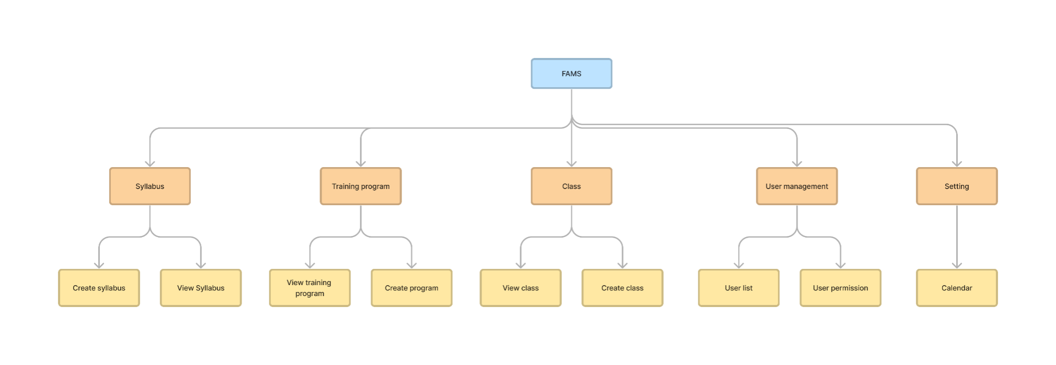

*Figure 4: FAMS site map*

# User Story Specifications

This section covers the user requirements which details what user must do in terms of input, behavior and the expected output. The user interfaces (UI) related to each user story are stored in Figma link.

## User management

This epic includes the user stories which have goals in user management functions such as create users, active/deactive users, add/update permission to user, ...

### View list of existed user / User listing screen

| **Description** | Allow admin to view list of existed user / User listing screen |
| --- | --- |
| **User Story ID** | US01 |
| **As a** | Admin |
| **I want** | I want to be able to view a list of existing user order by name |
| **So that** | so that I can manage all user and I can easily find and update their current information. |
| **Acceptance Criteria** | AC1: The list of fields that should be displayed are:  - From the syllabus: name, code, created_date, created_by, output_standards  - From training_content: sum(duration) as duration.  AC2: Table list view with default filter:  - syllabus status in ("Active", "Draft")  - syllabus list is ordered by created_date desc  - syllabus list is limited by 10 items per page (adjustable)  AC3: Syllabus status includes  - "Draft" if it is being saved as draft  - "Active" if it is published  - "Inactive" if it is de-activated  AC4: At the syllabus listing screen, User can sort the syllabus list by clicking on the sort of icon beside the field column name. |
| **Message** | N/A |
| **Reference** | UI: [Figma URL](https://www.figma.com/file/6tLNpYrNQwpAr7f4PfRua5/Practical-BA-2023_FAM?type=design&node-id=46-5329&mode=design&t=IuMaPjfGhpzjj6YZ-4) |

#### Screen item description

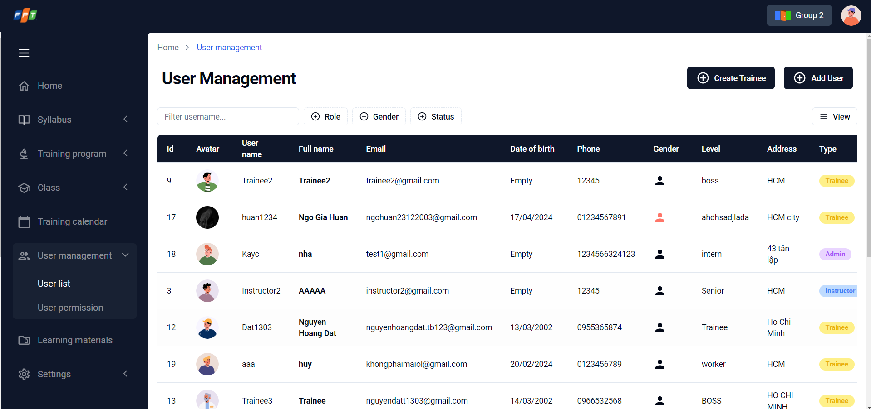

*Figure 10: View list of existed user / User listing screen*

| **No.** | **Screen element** | **Format Type** | **Require** | **Default show** | **Data type** | **Data table** | **Default value** | **Description** |
| --- | --- | --- | --- | --- | --- | --- | --- | --- |
| 1 | Quick search | input | N/A | Yes | text | - | N/A | Allow user input data and search as auto-completed search. Search results will be filtered & displayed as input letters.   * Searched by ID, Full name, Email * Searched conditions will be displayed right under the quick search textbox, as tag with grey color & “x” icon for deleting * Display maximum 4 tags (for 3 conditions: ID, Full name, Email) |
| 2 | Add user | button | N/A | Yes | N/A | - | N/A | Click on button to add a new user. Move to Create user screen. |
| 3 | Searched condition displaying | chip | N/A | N/A | N/A | - | N/A | Display searched result due to inputted search condition (quick search) |
| 4 | List - ID | label | N/A | N/A | Text | user.ID | N/A | Created user list with ID is displayed   * If there is no record: display text “Currently no records” |
| 5 | List – Full name | label | N/A | N/A | Text | user.name | N/A | Full name of user is displayed. |
| 6 | List - Email | label | N/A | N/A | Text | user.email | N/A | Email of user is displayed. |
| 7 | List – Date of birth | label | N/A | N/A | Date | user.dob | N/A | Date of birth of user is displayed (format: mm/dd/yyyy) |
| 8 | List – Gender | label | N/A | N/A | Icon | user.gender | N/A | Gender of user is displayed (differentiate by color) |
| 9 | List – Type | label | N/A | N/A | Text | user.role | N/A | Type of user is displayed |
| 10 | Popup menu | popup | N/A | N/A | N/A | - | N/A | Pop-menu icon is display. There are 3 selections   * Edit user: onclick to open Update user popup. * Change role: onclick to move to corresponded screen of that syllabus * De-activate/Activate user: Inactive temporarily due to be out-of-scope. |
| 11 | Paging | button | N/A | Yes | N/A | - | N/A | Refer 5.1.3. Search |
| 12 | Rows per page | button | N/A | Yes | N/A | - | N/A | Refer 5.1.11. Pagination |

### Create user

| **Description** | Allow admin to create a user |
| --- | --- |
| **User Story ID** | US02 |
| **As a** | Admin |
| **I want** | I want to create a user account |
| **So that** | so that user can access to FAM system |
| **Acceptance Criteria** | AC1: User able to fill all fields to create (User type, Name, email, phone, address, DOB, Level)  AC2: The message '<Field name> is required' (color: red) will be shown if there are any empty fields.  AC3: Username and password will be sent to user account via email after creating successfully.  + Method: Realtime email after creating an account successfully.  + Title: “[FAMS] - Tài khoản được tạo thành công”  + Body:  “Hi, <user.name>,  Tài khoản đăng nhập vào hệ thống FAMS của bạn đã được tạo thành công.  Vui lòng truy cập hệ thống theo thông tin sau:   * Username: <user.email> * Password: <auto password created by system>   **Lưu ý:** *Vui lòng thay đổi mật khẩu sau khi đăng nhập.”* |
| **Message** | **Refer: EM01 to EM09** |
| **Reference** | UI: [Figma URL](https://www.figma.com/file/6tLNpYrNQwpAr7f4PfRua5/Practical-BA-2023_FAM?type=design&node-id=46%3A6107&mode=design&t=3Mcd7hHiQfwxkdej-1) |

*Screen item description*

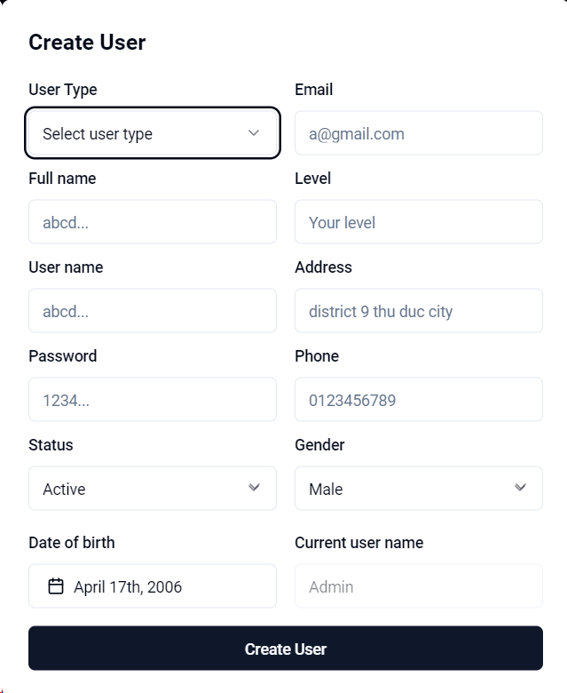

*Figure 5: Create a new user form*

| **No.** | **Screen element** | **Format Type** | **Require** | **Default show** | **Data type** | **Data table** | **Default value** | **Description** |
| --- | --- | --- | --- | --- | --- | --- | --- | --- |
| 1 | Create Userr | Header | N/A | Yes | N/A | N/A | N/A |  |
| 2 |  | button | N/A | Yes | N/A | N/A | N/A |  |
| 3 | User type | input | Yes | Yes | Datalist | user.role | N/A | * Allow user to choose the role including Super admin / Admin / Trainer * This field is required. If empty, the system will show message EM01 * Only Role “Super Admin” can create new user with role “Super Admin”. |
| 4 | Name | input | Yes | Yes | text | user.name | N/A | * Allow user to input the name of user. * This field is required. If empty, the system will show message EM02 |
| 5 | Email Address | input | Yes | Yes | text | user.email | N/A | * Allow user to input the email address. * This field is required. If empty, the system will show message EM03 * Validate email:   +If this email was existed, the system will show message EM04  + If format of email is incorrect, the system will show message EM05 |
| 6 | Phone | input | Yes | Yes | number | user.phone | N/A | * Allow user to input the phone number. * This field is required. If empty, the system will show message EM06 * Validate phone: If format of phone is incorrect, the system will show message EM07 |
| 7 | Date of birth | input | No | Yes | date | user.dob | N/A | * Allow user to input the date of birth. * This field is required. If empty, the system will show message EM08 |
| 8 | Gender | radio button | Yes | Yes | Option | user.gender | Male | * Allow user to choose the gender including Male / Female |
| 9 | Status | switch | Yes | Yes | Option | user.status | Active | * Allow user to choose the status including Active / Inactive. |
| 10 | Create User | button | N/A | Yes | N/A | N/A | N/A | User click 'Save' to create new user, show message EM09. |

### Update user

| **Description** | Allow admin to update user detail |
| --- | --- |
| **User Story ID** | US03 |
| **As a** | Admin |
| **I want** | I want to update user details |
| **So that** | so that user has the latest information |
| **Acceptance Criteria** | AC1. Users can update information such as user type, name, phone, DOB, Gender, Status. All of fields are mandatory one (cannot change email)  AC2. When user click save, the role will be update with new permission and the message ' Account are updated successfully' will be showed |
| **Message** | **Refer: US02 & EM10** |
| **Reference** | UI: [Figma URL](https://www.figma.com/file/6tLNpYrNQwpAr7f4PfRua5/Practical-BA-2023_FAM?type=design&node-id=46%3A6166&mode=design&t=3Mcd7hHiQfwxkdej-1) |

#### Screen item description

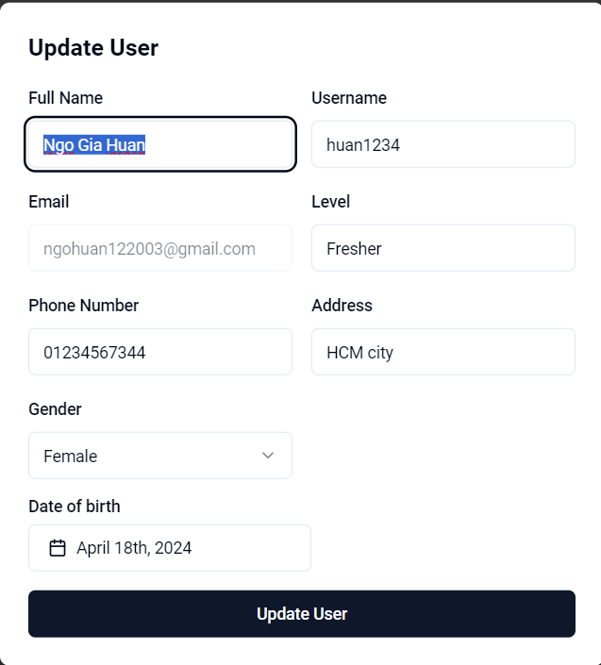

*Figure 6: Edit a user form*

| **No.** | **Screen element** | **Format Type** | **Require** | **Default show** | **Data type** | **Data table** | **Default value** | **Description** |
| --- | --- | --- | --- | --- | --- | --- | --- | --- |
| 1 | Update user | Header | N/A | Yes | N/A | N/A | N/A |  |
| 2 |  | button | N/A | Yes | N/A | N/A | N/A |  |
| 3 | User type | Text | Yes | Yes | Data list | user.role | Current type of user account | Loading the current data.  User cannot change current user type. |
| 4 | Name | Text | Yes | Yes | text | user.name | Current name of user account | Loading the current data.  Allow user to update the name. |
| 5 | Email Address | Text | Yes | Yes | text | user.email | Current mail of user account | Loading the current data  User cannot change current email. |
| 6 | Phone | Number | Yes | Yes | number | user.phone | Current phone of user account | Loading the current data  Allow user to update the phone number.  Validation Rule refers to creating new account (US02 - 3.1.2 item 6). |
| 7 | Date of birth | date | No | Yes | date | user.dob | Current phone of user account | Loading the current data  Allow user to update the date of birth |
| 8 | Gender | radio button | Yes | Yes | option | user.gender | Current Gender of user account | Loading the current data  Allow user to choose the gender including Male / Female |
| 9 | Status | switch | Yes | Yes | option | user.status | Current status of user account | Loading the current data  Allow user to choose the status including Active / Inactive. |
| 10 | Update User | button | N/A | Yes | N/A | N/A | N/A | User click 'Save' to update user details, show message EM10. |

### Grant permission to user account

| **Description** | Allow super admin to add permission to user account |
| --- | --- |
| **User Story ID** | US04 |
| **As a** | Super Admin |
| **I want** | I want to add permission to user account |
| **So that** | so that user will have a specific permission by their roles |
| **Acceptance Criteria** | User can choose one account and one role map together. After 'Save', the account will have a specific permission by their roles in the system. |
| **Message** | N/A |
| **Reference** | UI: [**Figma URL**](https://www.figma.com/file/6tLNpYrNQwpAr7f4PfRua5/Practical-BA-2023_FAM?type=design&node-id=46%3A6091&mode=design&t=2FZdBRcjGfOVcz0Z-1) |

#### Screen item description

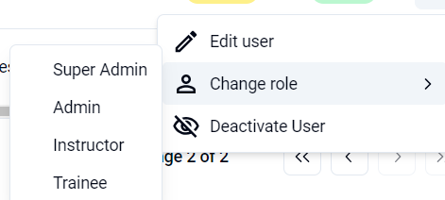

*Figure 7: Grant permission to user account*

| **No.** | **Screen element** | **Format Type** | **Require** | **Default show** | **Data type** | **Data table** | **Default value** | **Description** |
| --- | --- | --- | --- | --- | --- | --- | --- | --- |
| 1 | Change role | Drop-down list | N/A | Yes | Option | user.role | N/A | Only clickable with Super admin  Click on -> show a drop-down list with three options   * Super Admin * Class Admin * Trainer |

### View permission

| **Description** | Allow admin to view permission matrix |
| --- | --- |
| **User Story ID** | US05 |
| **As a** | Admin |
| **I want** | I want to view permission matrix |
| **So that** | so that I can know the specific permission of each role |
| **Acceptance Criteria** | AC: User can view all the roles in User permission tab.  There are 6 columns in the permission matrix: Role name, Training program, Class, Learning material and User.  In each column will show the detail permission for the current role: Access denied, view, modify, create, full access. |
| **Message** | **N/A** |
| **Reference** | UI: [**Figma URL**](https://www.figma.com/file/6tLNpYrNQwpAr7f4PfRua5/Practical-BA-2023_FAM?type=design&node-id=46%3A5865&mode=design&t=3Mcd7hHiQfwxkdej-1) |

#### Screen item description

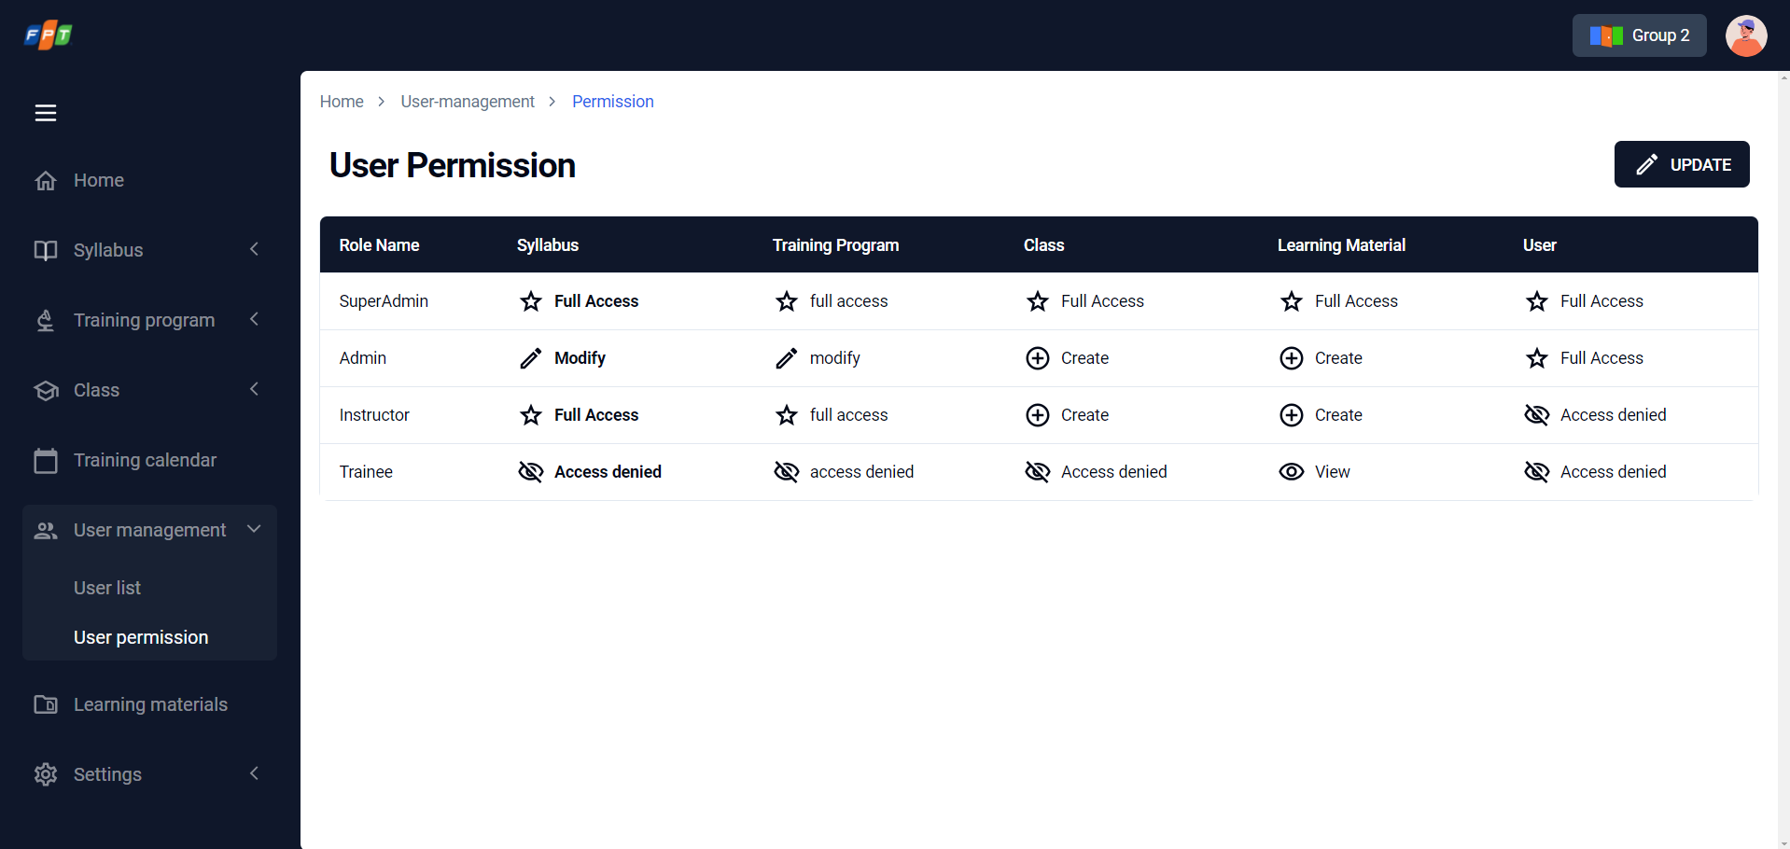

*Figure 8: View permission*

| **No.** | **Screen element** | **Format Type** | **Require** | **Default show** | **Data type** | **Data table** | **Default value** | **Description** |
| --- | --- | --- | --- | --- | --- | --- | --- | --- |
| 1 | User Permission | Header | N/A | Yes | N/A | N/A | N/A |  |
| 2 | Update permission | button | N/A | Yes | N/A | N/A | N/A |  |
| 3 | Data Grid | Data Grid | N/A | Yes | Option Set | N/A | Current user permission. | User can view the current permission matrix of all roles. |

### Update role permission

| **Description** | Allow admin to update permission to user account |
| --- | --- |
| **User Story ID** | US06 |
| **As a** | Admin |
| **I want** | I want to update permission to user account |
| **So that** | so that all users which are belong to the same role can be updated their permission. |
| **Acceptance Criteria** | AC1. User has permission to edit permission in role when user access the permission tab then user can see all the permission groups that exist in the system then the role will be update with new permission.  AC2. The message 'Role are updated successfully' will be showed when User updated permission successfully. |
| **Message** | **Refer: EM11** |
| **Reference** | UI: [**Figma URL**](https://www.figma.com/file/6tLNpYrNQwpAr7f4PfRua5/Practical-BA-2023_FAM?type=design&node-id=46%3A5648&mode=design&t=3Mcd7hHiQfwxkdej-1) |

*Screen item description*

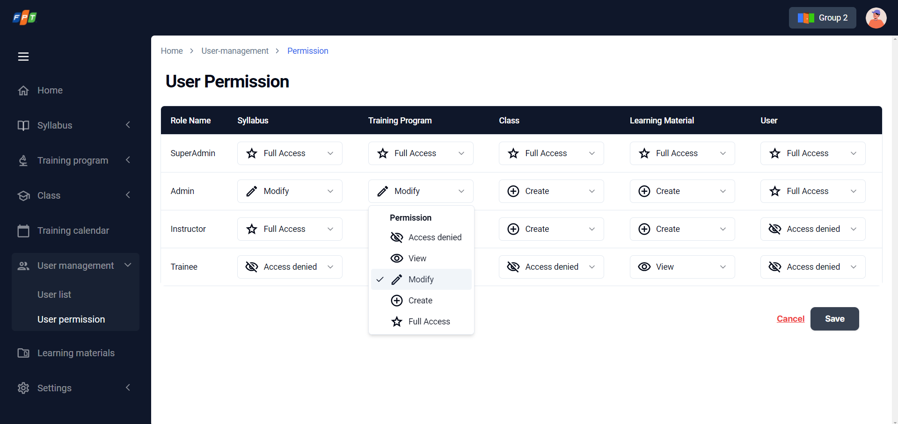

*Figure 9: Update user permission*

| **No.** | **Screen element** | **Format Type** | **Require** | **Default show** | **Data type** | **Data table** | **Default value** | **Description** |
| --- | --- | --- | --- | --- | --- | --- | --- | --- |
| 1 | User Permission | Header | N/A | Yes | N/A | N/A | N/A |  |
| 2 | Update permission | button | N/A | Yes | N/A | N/A | N/A |  |
| 3 | Data Grid | Data Grid | N/A | Yes | Data list | N/A | Current Permision | 1. Users can update permission of each entity (Syllabus, Training Program, Class, Learning material) including levels: Access Denied, View, Modify, Create, Full Access). 2. Role “Admin” can not change permission of Role “Super Admin” 3. The default permission of Entity “User” is:   + Role Super Admin: Full Access  + Role Admin: Create  + Role Trainer: View |
| 4 | Save | button | N/A | Yes | N/A | N/A | N/A | Users click 'Save' to create new user, show message EM11 |
| 5 | Cancel | button | N/A | Yes | N/A | N/A | N/A | Users click 'Cancel' to update role permission. |

## Management syllabus

### View list of existed syllabus/ Syllabus listing screen

| **Description** | Allow admin to view list of existed syllabus / Syllabus listing screen |
| --- | --- |
| **User Story ID** | US07 |
| **As a** | Admin |
| **I want** | I want to be able to view a list of existing syllabus order by created_date |
| **So that** | so that I can overview all syllabus from the newest to the oldest and I can easily find and modify current syllabuses. |
| **Acceptance Criteria** | AC1: The list of fields that should be displayed are:  - From the syllabus: name, code, created_on, created_by, output_standards  - From training_content: sum(duration) as duration.  AC2: Table list view with default filter:  - syllabus status in ("Active", "Draft", “InActive ”)  - syllabus list is limited by 10 items per page (adjustable)  AC3: Syllabus status includes  - "Draft" if it is being saved as draft  - "Active" if it is published  - "Inactive" if it is de-activated  AC4: At the syllabus listing screen, User can sort the syllabus list by clicking on the sort of icon beside the field column name. |
| **Message** | N/A |
| **Reference** | UI: [**Figma URL**](https://www.figma.com/file/6tLNpYrNQwpAr7f4PfRua5/Practical-BA-2023_FAM?type=design&node-id=252-17308&mode=design&t=sBMsXVYgvEBou6S8-4) |

#### Screen item description

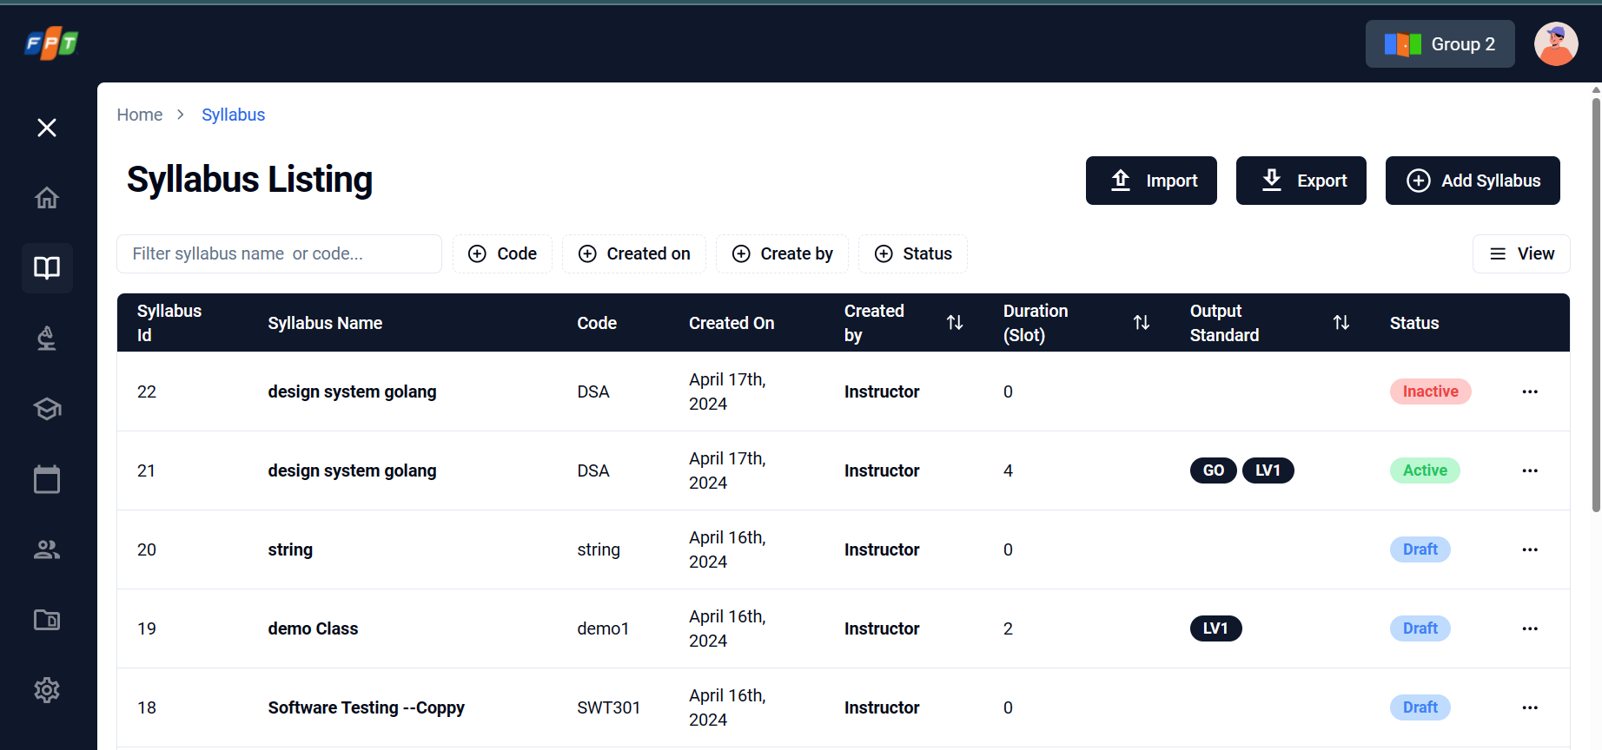

*Figure 10: View list of existed syllabus / Syllabus listing screen*

| **No.** | **Screen element** | **Format Type** | **Require** | **Default show** | **Data type** | **Data table** | **Default value** | **Description** |
| --- | --- | --- | --- | --- | --- | --- | --- | --- |
| 1 | Quick search | input | N/A | Yes | text | - | N/A | Allow user input data and search as auto-completed search. Search results will be filtered & displayed as input letters.   * Searched by name * Searched conditions will be displayed right under the quick search textbox, as tag with grey color & “x” icon for deleting * Display maximum 4 tags (for 4 conditions: name, code, output_standards, created_date, created_by) |
| 2 | Search by created date | input | N/A | Yes | Date | - | N/A | Click on field to display date picker calendar |
| 3 | Search by create date calendar | Calendar picker | N/A | Yes | option set | - | N/A | Select a date or date duration depends on choosing way   * One clicks in a date: pick a date * Same one clicks in chosen date: release picked date * One click in a date AND one more click in other date: pick a duration |
| 4 | Import | button | N/A | Yes | N/A | - | N/A | Allow to open the syllabus import popup |
| 5 | Add syllabus | button | N/A | Yes | N/A | - | N/A | Click on button to add a new syllabus. Move to Create Syllabus screen with default is General tab |
| 6 | Searched condition displaying | chip | N/A | N/A | N/A | - | N/A | Display searched result due to inputted search condition (quick search & calendar picker) |
| 7 | List -Syllabus | label | N/A | N/A | N/A | Syllabus.topic_  name | N/A | Created syllabus list is displayed   * If there is no record: display text “Currently no records” |
| 8 | List - Code | label | N/A | N/A | N/A | Syllabus.topic_  Code | N/A | Code of syllabus is displayed (format: 3 or more alphabet letters) |
| 9 | List - Created date | label | N/A | N/A | N/A | Syllabus.topic_  Created_date | N/A | Create date of syllabus is displayed (format: mm/dd/yyyy) |
| 10 | List – Created by | label | N/A | N/A | N/A | User.Full_name | N/A | User who created syllabus is displayed |
| 11 | List – Duration | label | N/A | N/A | N/A | Training_program.Duration | N/A | Duration of syllabus is displayed (format: {integer number} days) |
| 12 | List – Output standard | label | N/A | N/A | N/A | - | N/A | Output standard of syllabus is displayed (format: as tag)   * Maximum display: 3 tags. * If there is more than 3 tags: display tags & “...” icon for seeing more * Onclick to “...” icon to move to Syllabus Detail screen |
| 13 | List – Status | label | N/A | N/A | N/A | Training_program.status | N/A | Status of syllabus is displayed (format: Active/Drafting/Inactive as tag) |
| 14 | Three dots button | Button | N/A | N/A | N/A | - | N/A | Popup-menu icon is displayed. There are 4 selections   * View Syllabus: onclick to move to syllabus’s detail screen * Edit syllabus: onclick to move to corresponded screen of that syllabus * Duplicate syllabus: onclick to copy a new syllabus with same content (but different topic code in DB). After duplicated, detail screen is appeare and status is draft. * Change status: onclick to change the status of syllabus to: Active, InActive, Draft |
| 15 | Paging | button | N/A | Yes | N/A | - | N/A | Refer 5.1.3. Search |
| 16 | Rows per page | button | N/A | Yes | N/A | - | N/A | Refer 5.1.11. Pagination |

### Create Syllabus (General Tab)

| **Description** | Allow admin to create syllabus |
| --- | --- |
| **User Story ID** | US08 |
| **As a** | Admin |
| **I want** | I want to be able to create a general information of a syllabus |
| **So that** | so that I can input/store important information about the training program I am going to handle |
| **Acceptance Criteria** | AC1_At General tab  GIVEN user has permission to Create a syllabus  AND user is at the creating syllbus page  THEN user should be able to input the syllabus name  AND user can select the level  AND user can input the attendee number  AND user can input the technical requirements as free text  AND user can input the course objectives as free text area  THEN user can save the syllabus to go to next tab  OR user can save the creation as a draft  AC2. User should be able to see the progress bar as the current tab |
| **Message** | Refer: EM12 to EM16 |
| **Reference** | UI: [**Figma URL**](https://www.figma.com/file/NQEXjnlUgG5YRvE5KsqtDR/FA_training_system_260822-BA_PRAC_class?type=design&node-id=163-4344&mode=design) |

#### Screen item description

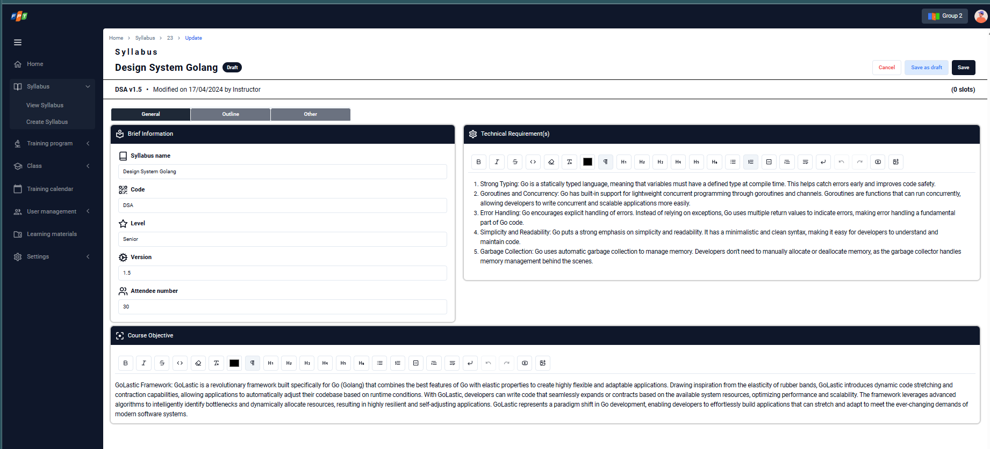

*Figure 11: Create syllabus form*

| **No.** | **Screen element** | **Format Type** | **Require** | **Default show** | **Data type** | **Data table** | **Default value** | **Description** |
| --- | --- | --- | --- | --- | --- | --- | --- | --- |
| 1 | Syllabus | Header | N/A | Yes | N/A | - | N/A |  |
| 2 | Steps gauge bar | Process bar | N/A | Yes | N/A | - | N/A | Default General is filled  Each step is fulfil & successfully save: Gain & filled |
| 3 | Syllabus Name | Input | Yes | Yes | text | Syllabus.topic name | N/A | Input syllabus name  Allow to input maximum 60 letters.  If empty, the system will show message EM12. |
| 4 | Code | Label | N/A | Yes | text | Syllabus.topic code | NPL | Manual input code |
| 5 | Version | Label | N/A | Yes | number | Syllabus. version | 1.0 | Allow user to input the phone number  - format: i1.i2.i3  - i1 is for big updates, the user can change i1 manually. The default value is 1.  - i2 is for the published version, autogenerated by the system. |
| 6 | Level | Dropdown list | Yes | All level | selection | user.level | Äuto detect | Allow admin select level for the course including Beginner  Or manul text input/ Advanced...  If empty, the system will show message EM13. |
| 7 | Attendee number | input | Yes | Yes | number | Syllabus.training_audience | N/A | Allow admin input attendee number.  If empty, the system will show message EM14. |
| 8 | Technical Requirements | input | Yes | Yes | Text area | Syllabus.tectnical_group | N/A | Allow admin input technical requirement information.  If empty, the system will show message EM15. |
| 9 | Course objectives | input | Yes | Yes | Text area with editor | N/A | N/A | Allow admin input Course objectives.  If empty, the system will show message EM16. |
| 10 | Time allocation table | Pie chart & list | N/A | Yes | label | Training_content.duration | N/A | Allow admin check time allocation of each delivery type. |
| 11 | Cancel | button | N/A | Yes | N/A | N/A | N/A | Click to cancel creating a new syllabus.  After clicked, screen moves to outline tab |
| 12 | Save as draft | button | N/A | Yes | N/A | N/A | N/A | Click to save as draft and move to Syllabus screen automatically after complete saving.  Draft record will have a tag “Draft” in Status column in List Syllabus table  Only able to save as draft when Syllabus Name is filled. |
| 13 | Save | button | N/A | Yes | N/A | N/A | N/A | Click to save all the inputted data with outline and other is null |

### Create Syllabus (Outline Screen)

| **Description** | Allow admin to fill the syllabus outline information |
| --- | --- |
| **User Story ID** | US09 |
| **As a** | Admin |
| **I want** | I want to fill the syllabus outline information on a separate screen |
| **So that** | so that I can fulfill all general information before going to next step of creating syllabus |
| **Acceptance Criteria** | Admin click edit the syllabus to view edit page.  This screen displays the edit screen, admin move to outline screen, besides basic information, it focuses on creating syllabus schedule items like Slots, contents (Unit) and materials .  AC1: Display the progress bar which show the current step that the user is filling "outline" information and what are the next steps  AC2: In this screen, User can add/remove a new slot  AC3: In each slot, the user can add/edit/remove new content/training material by uploading a file/attaching a link to that content.  AC4: Required fields to create new content include name, outputStandard (from dropdown menu), duration (0 minutes - 480 minutes), training format (online/offline), and delivery type (from dropdown menu).  AC5: Display time allocation chart. Time allocation is automatically recalculated everytime training content is added/removed/edited. |
| **Message** | Refer: EM17 to EM26, EM40 |
| **Reference** | UI: [**Figma URL**](https://www.figma.com/file/NQEXjnlUgG5YRvE5KsqtDR/FA_training_system_260822-BA_PRAC_class?type=design&node-id=123552-11728&mode=design) |

#### Screen item description

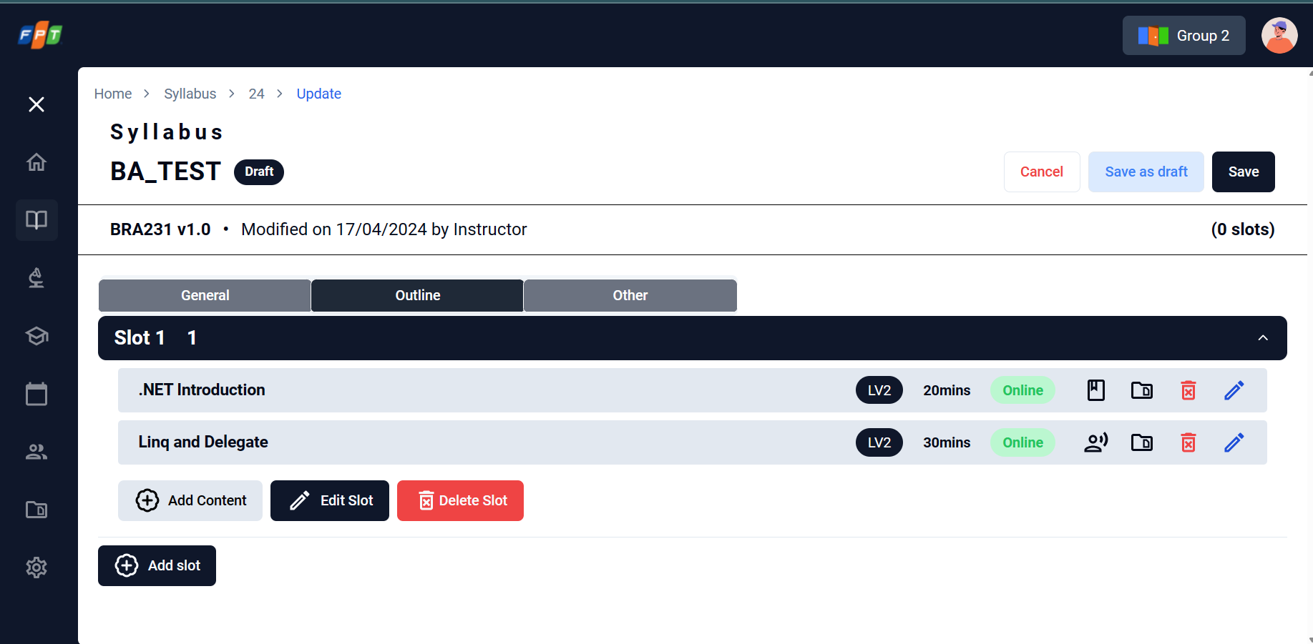

*Figure 13: Syllabus outline information form*

| **No.** | **Screen element** | **Format Type** | **Require** | **Default show** | **Data type** | **Data table** | **Default value** | **Description** |
| --- | --- | --- | --- | --- | --- | --- | --- | --- |
| 1 | Added Day | icon | N/A | Yes | N/A | Training_unit | N/A | Allow view days in outline |
| 2 | Unit in a day | label | N/A | Yes | N/A | Training_unit.unit_name | N/A | Display the unit of the syllabus. The Unit number is sequence started from 1 |
| 3 | Expand/Collapse icon | icon | N/A | Yes | N/A | N/A | N/A | Allow expand or collapse the units |
| 4 | Unit - Edit (pencil symbol icon) | icon | N/A | Yes | N/A | N/A | N/A | Allow to re-name a unit and show Delete Content icon () for contents included inside relevant unit.  After clicking Delete content icon, the relevant content will disappear. |
| 5 | Add slot | Button | N/A | Yes | N/A | N/A | N/A | Allow to add new slots in outline |
| 6 | Delete slot | icon | N/A | Yes | N/A | N/A | N/A | Allow to delete slots in outline |
| 7 | Delete slot pop-up | Pop-up | N/A | Yes | N/A | N/A | N/A | Confirm delete pop-up is displayed when a slot in outline is deleted. (refers to EM22) |
| 8 | Delete slot pop-up – Cancel button | button | N/A | Yes | N/A | N/A | N/A | Cancel/Not delete selected slot |
| 9 | Delete slot pop-up – Delete | button | N/A | Yes | N/A | N/A | N/A | Confirm deleting selected slot |
| 10 | Add unit item for a slot | button | N/A | Yes | N/A | N/A | N/A | Allow add a new unit in corresponded slot |
| 11 | Input unit name textbox | input | N/A | Yes | text | Training_unit.  unit_name | N/A | Allow input name for the unit |
| 12 | Create Unit name button | button | N/A | Yes | N/A | N/A | N/A | Onclick to save inputted name of unit.  If the name is empty, the system will show message EM17. |
| 13 | Add unit item for an unit | icon | N/A | Yes | N/A | N/A | N/A | Onclick to open a New Content popup to add a new content in the unit. |
| 14 | New Content - Name | input | Yes | Yes | Text | Training_content.content | N/A | Allow input name for the content.  If the name is empty, the system will show message EM18. |
| 15 | New Content – Output standard | input | Yes | Yes | Multi-selection | Training_content.learning_objective | N/A | Allow input Output standard for the content.  If the name is empty, the system will show message EM19. |
| 16 | New Content – Duration | input | Yes | Yes | Minute | Training_content.duration | N/A | Allow input Training time for the content.  If the name is empty, the system will show message EM20. |
| 17 | New Content - Delivery type | Dropdown list | Yes | Yes | Option | Training_content.delivery_type | N/A | Allow input Delivery type for the content from dropdown list If the name is empty, the system will show message EM21. |
| 18 | New Content - Method | switch | Yes | Yes | Option | Training_content.training_format | Online | Allow input Method for the content including Online/Offline |
| 19 | New Content – Cancel button | button | N/A | Yes | N/A | N/A | N/A | Click to cancel creating a new content & close pop-up. After clicked, screen moves to View Syllabus screen - Outline tab. |
| 20 | New Content – Create button | button | N/A | Yes | N/A | N/A | N/A | Click to temporarily save all the inputted data and move to View Syllabus screen - Outline tab. |
| 21 | Output standard | chip | N/A | Output standard | selection | Training_content.learning_objective | N/A | Display output standard for corresponded lecture |
| 22 | Lecture duration | input | N/A | No | number | Training_content.  Duration | N/A | Display the duration of lecture |
| 23 | Lecture training format | switch | N/A | Online | N/A | Training_content.  Training_format | N/A | Display training format for corresponded lecture (Online/Offline) |
| 24 | Lecture delivery type | Dropdown list | N/A | Delivery type | selection | Training_content.  Delivery_type | N/A | Display delivery type for lecture  (Concept/Lecture, Assignment/Lab, Guides/Review, Test/Quiz, Exam) |
| 25 | Lecture material upload icon | icon | N/A | No | N/A | Syllabus.training_materials | N/A | Onclick to open upload/edit/delete training materials for each lecture |
| 26 | Training material popup – Upload new | button | N/A | No | N/A | Syllabus.training_materials | N/A | Open browser to select training materials   * Allowed upload file/extension: image, pdf, ppt, video, xls * Maximum size: 25MB * If the selected file is invalid, the system will show message EM40. |
| 27 | Training material popup – Uploaded file | hyperlink | N/A | No | N/A | Syllabus.training_materials | N/A | Displayed uploaded material files as hyperlink (format: {filename}.{extension})   * Onclick to download file |
| 28 | Training material – uploaded by information | Text | N/A | No | N/A | N/A | N/A | Displayed information of uploaded person & date time (format: by {uploaded person name} on {dd/mm/yyyy} |
| 29 | Training material – edit icon (pencil icon) | icon | N/A | No | N/A | N/A | N/A | Click to edit/re-upload uploaded file |
| 30 | Training material – delete icon | icon | N/A | No | N/A | N/A | N/A | Onclick to delete/remove corresponded material file |
| 31 | Training material – Cancel | button | N/A | N/A | N/A | - | N/A | Click to close pop-up.  After clicked, screen moves to View Syllabus screen - Outline tab. |
| 32 | Time allocation table | Pie chart & list | N/A | Yes | label | Training_content.duration | N/A | Allow admin check time allocation of each delivery type. |
| 33 | Previous | button | N/A | Yes | N/A | N/A | N/A | Onclick to go back to General tab |
| 34 | Cancel | button | N/A | Yes | N/A |  | N/A | Click to cancel creating a new syllabus.  After clicked, screen moves to View Syllabus screen |
| 35 | Save as draft | button | N/A | N/A | N/A | - | N/A | Click to save as draft  Only able to save as draft when Syllabus Name is filled. |
| 36 | Save | button | N/A | Yes | N/A |  | N/A | Click to save the inputted data.  If there is no day inputted, the system will show message EM23.  If there is a day has no unit inputted, the system will show message EM24.  If there is a unit has no content inputted, the system will show message EM25.  If the total duration of a day exceeds 8 hours, the system will show message EM26. |
|  |  |  |  |  |  |  |  |  |

### Create Syllabus (Other Screen)

| **Description** | Allow admin to fill the syllabus outline information |
| --- | --- |
| **User Story ID** | US10 |
| **As a** | Admin |
| **I want** | I want to fill the syllabus outline information on a separate screen |
| **So that** | so that I can fulfill all general information before going to next step of creating syllabus |
| **Acceptance Criteria** | This screen focuses on inputting assessment schemes and training delivery principles.  AC1: The progress bar shows the current step that the user is filling "other" information  AC2: User can input assessment scheme for items including quiz, assignment, final theory test, and final practice test. The total is 100% when all assessment scheme is fulfilled.  AC3: User can input passing criteria  AC4: User can input training delivery principles with editor tool |
| **Message** | Refer: EM27 to EM33 |
| **Reference** | UI: [**Figma URL**](https://www.figma.com/file/NQEXjnlUgG5YRvE5KsqtDR/FA_training_system_260822-BA_PRAC_class?type=design&node-id=123552-11728&mode=design) |

#### Screen item description

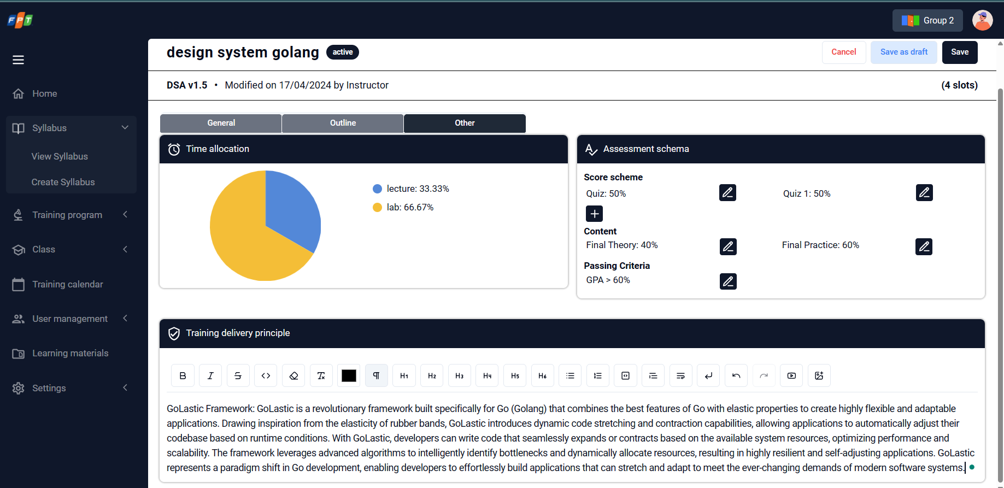

*Figure 14: Syllabus other information forms*

| **No.** | **Screen element** | **Format Type** | **Require** | **Default show** | **Data type** | **Data table** | **Default value** | **Description** |
| --- | --- | --- | --- | --- | --- | --- | --- | --- |
| 1 | Time allocation table | Pie chart & list | N/A | Yes | label | Training_content.duration | N/A | Allow admin check time allocation of each delivery type. |
| 2 | Assessment scheme input textbox | input | Yes | Yes | Percent number | - | N/A | Allow set percent number for assessment scheme  (Quiz, Assignment, Final, Final Theory, Final Practice, GPA of Passing Criteria)  Only integer number is allowed.  If empty, the system will show message EM27~EM32 for the relevant item. |
| 3 | Training delivery principle | input | No | Yes | Text area with editor | - | N/A | Allow input training delivery principle. |
| 4 | Cancel | button | N/A | Yes | N/A |  | N/A | Click to cancel creating a new syllabus. After clicked, screen moves to View Syllabus’s detail screen |
| 5 | Save as draft | button | N/A | Yes | N/A |  | N/A | Click to save as draft (Only able to save as draft when Syllabus Name is filled) |
| 6 | Save | button | N/A | Yes | N/A |  | N/A | Click to save all the inputted data to complete creating & check inputted format for Assessment scheme input areas:   * If total of all data is not equal 100% display error message EM33 |

### Read syllabus information/Syllabus detail information screen (Admin)

| **Description** | Allow admin to read all detail information of the syllabus |
| --- | --- |
| **User Story ID** | US11 |
| **As a** | Admin |
| **I want** | I want to be able to read all detail information of the syllabus |
| **So that** | so that I can understand what syllabus is talking about and answer trainee if they have question |
| **Acceptance Criteria** | AC1: At the list syllabus screen, User can read syllabus information by clicking the syllabus code or name on the syllabus list to redirect to the syllabus detail information screen.  AC2: With the drafting syllabus, the syllabus detail information screen is the same as the edit screen at US 14 story.  AC3: With a published syllabus, user can read all syllabus information but can not edit them, if the user wants to edit, duplicate, and deactivate the syllabus, they must click on the syllabus manage button.  AC4: At syllabus detail information screen, The default displayed version of the syllabus is the latest version. User can pick a version on the version list to view other versions of the syllabus. |
| **Message** | N/A |
| **Reference** | UI: [**Figma URL**](https://www.figma.com/file/NQEXjnlUgG5YRvE5KsqtDR/FA_training_system_260822-BA_PRAC_class?type=design&node-id=123552-11728&mode=design) |

#### Screen item description (refer Create Syllabus (General/Outline/Others) – Figure 12, 13, and 14)

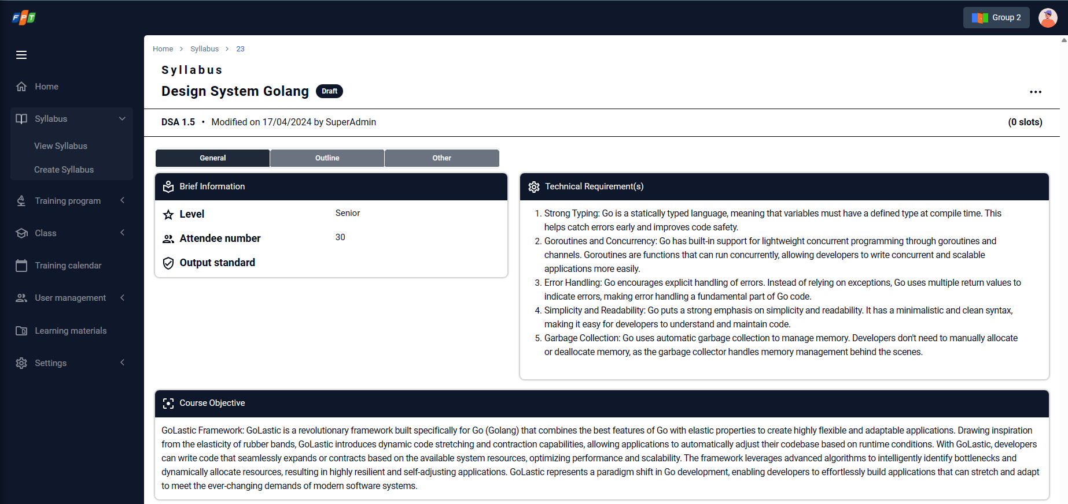

*Figure 15: Detail information of the syllabus (General tab)*

| **No.** | **Screen element** | **Format Type** | **Require** | **Default show** | **Data type** | **Data table** | **Default value** | **Description** |
| --- | --- | --- | --- | --- | --- | --- | --- | --- |
| 1 | Syllabus | Header | N/A | Yes | N/A | - | N/A | Display syllabus as page title |
| 2 | Syllabus Name | Input | Yes | Yes | text | Syllabus_ topic name | N/A | Display syllabus name |
| 3 | Active/De-active label | Label | N/A | Yes | text | Syllabus.public_status | N/A | Display active status of current syllabus (Active/De-active) |
| 4 | Code | Label | N/A | Yes | text | Syllabus_topic code | N/A | Display auto-generated code for current syllabus, format: <objective types A/S/K/H><sequence>. E.g. A01, S01, K05 |
| 5 | Version | Label | N/A | Yes | number | version | N/A | Display version of current syllabus. |
|  |  |  |  |  |  |  |  |  |
| 6 | Updated time information | Label | N/A | Yes | text | Syllabus.modified_date & Syllabus.modified_by | N/A | Display information of modified date & by who   * Format: Modified on mm/dd/yyyy by {user.full_name} |
| 7 | Level | Label | N/A | Yes | text | User.level | N/A | Display level of current syllabus |
| 8 | Attendee number | Label | Yes | Yes | text | Syllabus.training_audience | N/A | Display attendee number of current syllabus |
| 9 | Output standard | Tag label | Yes | Yes | text | - | N/A | Allow view Technical Requirement(s) value |
| 10 | Technical requirement | Label | Yes | Yes | Text | Syllabus_tectnical_group | N/A | Allow view Technical Requirement(s) value |
| 11 | Course Objective | Label | Yes | Yes | Text | Learning_objective.type | N/A | Allow view Object type data |
| 12 | Pop-up menu | icon | Yes | Yes | icon |  | N/A | Onclick to display pop-up menu   * View detail of Syllabus * Edit Syllabus: move to edit screen (Refer 3.2.9. Edit Syllabus) * Duplicate syllabus: refer 3.2.1. Syllabus List * De-active syllabus: allow to change status of current syllabus from Active to InActive |

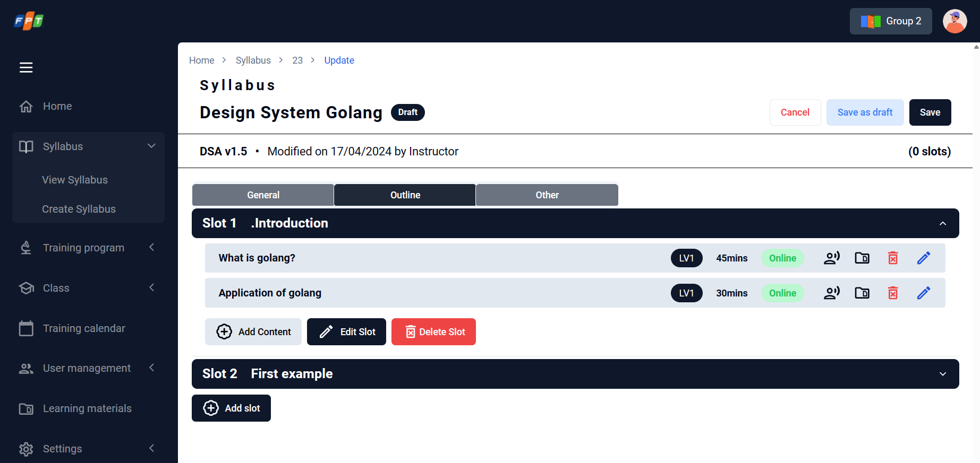

*Figure 16: View Syllabus (Outline)*

| **No.** | **Screen element** | **Format Type** | **Require** | **Default show** | **Data type** | **Data table** | **Default value** | **Description** |
| --- | --- | --- | --- | --- | --- | --- | --- | --- |
| 1 | Added Slot | icon | N/A | Yes | N/A | Training_unit | N/A | Allow view slot in outline |
| 2 | Unit in a slot | text | N/A | No | N/A | Training_unit & Training_content.Delivery_type | N/A | Allow view units in a slot in outline with:   * Unit name, duration * Lecture, lecture duration, lecture output standard, training format, delivery type, material |
| 3 | Expand/Collapse icon | icon | N/A | No | N/A | N/A | N/A | Allow expand or collapse slot |
| 19 | Lecture material folder icon | icon | N/A | No | N/A | Syllabus.training_materials | N/A | Onclick to open view/upload/edit/delete training materials for each lecture |
| 20 | Training material popup - Ⓧ icon | icon | N/A | No | N/A | N/A | N/A | Onclick for close training material pop-up |
| 21 | Training material popup – Upload new | button | N/A | No | N/A | Syllabus.training_materials | N/A | Open browser to select training materials   * Allowed upload file/extension: image, pdf, ppt, video, xls * Maximum size: 25MB |
| 22 | Training material popup – Uploaded file | hyperlink | N/A | No | N/A | Syllabus.training_materials | N/A | Displayed uploaded material files as hyperlink (format: {filename}.{extension})   * Onclick to download file |
| 23 | Training material – uploaded by information | Text | N/A | No | N/A | N/A | N/A | Displayed information of uploaded person & date time (format: by {uploaded person name} on {dd/mm/yyyy} |
| 24 | Training material – edit icon (pencil icon) | icon | N/A | No | N/A | N/A | N/A | Click to edit/re-upload uploaded file |
| 25 | Training material – delete icon | icon | N/A | No | N/A | N/A | N/A | Onclick to delete/remove corresponded material file |
| 29 | Time allocation table | table | N/A | Yes | label | Training_content.duration & training_content.delivery_type | N/A | Allow check time allocation of each delivery type |

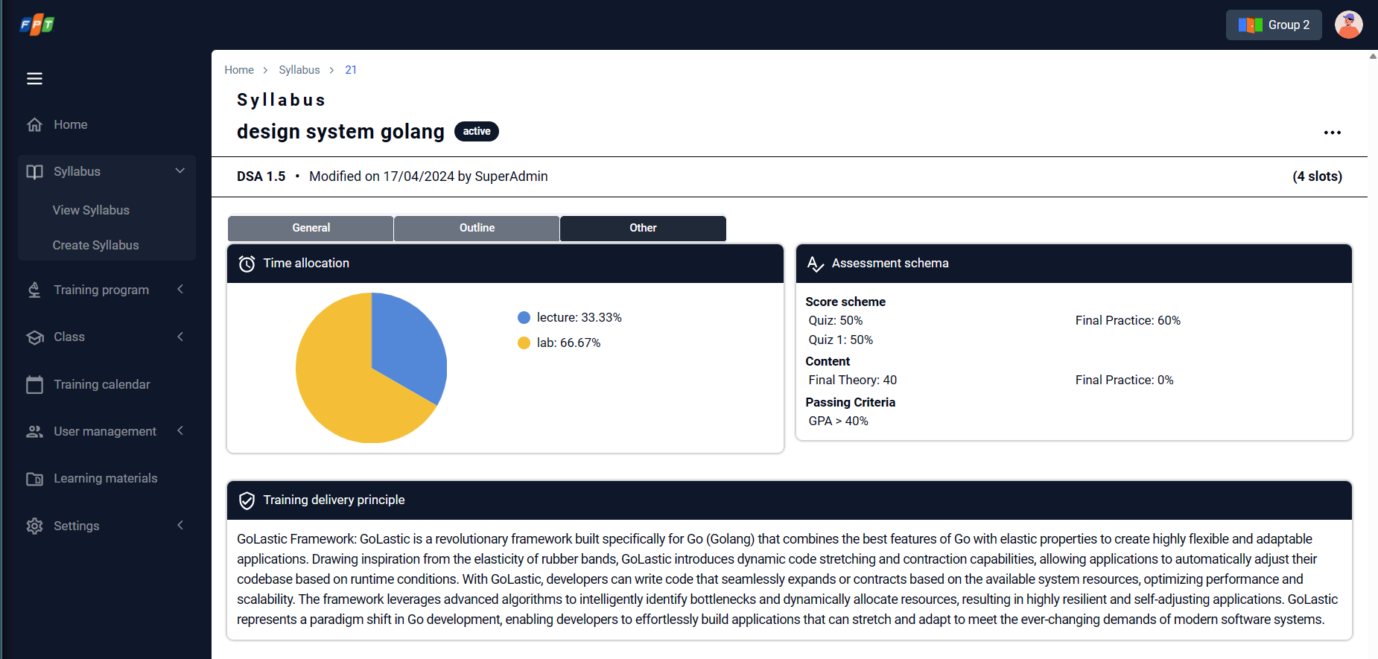

*Figure 17: View Syllabus (Others)*

| **No.** | **Screen element** | **Format Type** | **Require** | **Default show** | **Data type** | **Data table** | **Default value** | **Description** |
| --- | --- | --- | --- | --- | --- | --- | --- | --- |
| 1 | Time allocation table | table | N/A | Yes | label | Training_content.duration & training_content.delivery_type | N/A | Allow view time allocation of each delivery type |
| 2 | Assessment scheme | text | N/A | Yes | text | Training_content.duration & training_content.delivery_type | N/A | Allow view percent number for assessment scheme (Quiz, Assignment, Final, Final Theory, Final Practice, GPA of Passing Criteria) |
| 3 | Training delivery principle | Text editor | N/A | Yes | text | Syllabus.principles | N/A | Allow view training delivery principle |

### Read syllabus information/Syllabus detail information screen (Instructor)

| **Description** | Allow instructor to update information of existed syllabus |
| --- | --- |
| **User Story ID** | US12 |
| **As a** | Instructor |
| **I want** | I want to be able to read all detail information of the syllabus |
| **So that** | so that I can understand what syllabus is talking about and answer trainee if they have question |
| **Acceptance Criteria** | AC1: At the list syllabus screen, User can read syllabus information by clicking the syllabus code or name on the syllabus list to redirect to the syllabus detail information screen.  AC2: With the drafting syllabus, the syllabus detail information screen is the same as the edit screen at Syl5 story.  AC3: With a published syllabus, user can read all syllabus information but can not edit them, if the user wants to edit, duplicate, and deactivate the syllabus, they have to click on the syllabus manage button.  AC4: At syllabus detail information screen, The default displayed version of the syllabus is the latest version. User can pick a version on the version list to view other versions of the syllabus. |
| **Message** | N/A |
| **Reference** | UI: [**Figma URL**](https://www.figma.com/file/NQEXjnlUgG5YRvE5KsqtDR/FA_training_system_260822-BA_PRAC_class?type=design&node-id=123552-11728&mode=design) |

#### Screen item description (Refer Figure 15, 16, and 17)

### Update/edit syllabus information

| **Description** | Allow Admin to update information of existed syllabus |
| --- | --- |
| **User Story ID** | US13 |
| **As a** | Admin |
| **I want** | I want to be able to update information of existed syllabus |
| **So that** | so that I can update the newest and exact information of the syllabus |
| **Acceptance Criteria** | AC1: At the syllabus detail information screen, User can edit syllabus information in the same way to create them by clicking on "Edit" button, which is inside the syllabus manage button or .  AC2: Auto-generated fields including topic code, time_allocation are unable to update (version can). |
| **Message** | Refer: EM12 to EM33 |
| **Reference** | UI: [**Figma URL**](https://www.figma.com/file/NQEXjnlUgG5YRvE5KsqtDR/FA_training_system_260822-BA_PRAC_class?type=design&node-id=123552-11728&mode=design) |

#### Screen item description (Refer Figure 12, 13, and 14)

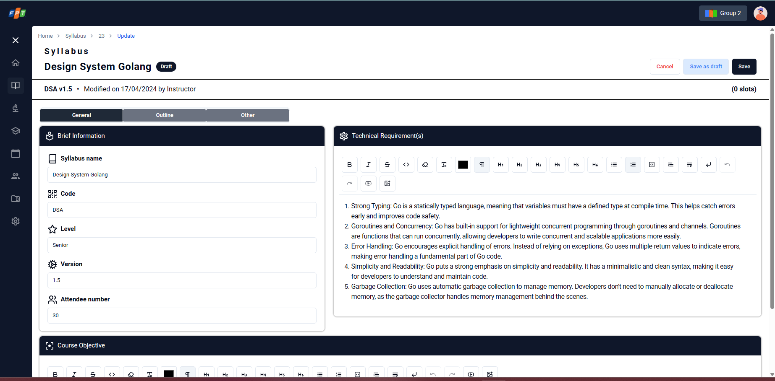

### Import syllabus/ syllabus importing screen

| **Description** | Allow admin to create a new syllabus through importing CSV/excel file |
| --- | --- |
| **User Story ID** | US14 |
| **As a** | Admin |
| **I want** | I want to be able to create a new syllabus through importing CSV/excel file |
| **So that** | so that I can save my time to ingest one existed syllabus by CSV/excel file without filling every field in manually |
| **Acceptance Criteria** | AC1: At the syllabus listing screen, User can upload Excel/CSV file to create a syllabus following 3 duplicate control options including allow, replace, and skip by clicking import button.  AC2: The imported file has to meet all validation conditions like when creating a new syllabus or it will notify errors to user.  AC3: At the syllabus importing screen, User can download the template of the import file. |
| **Message** | Refer: EM34 |
| **Reference** | 1. UI: [**Figma URL**](https://www.figma.com/file/NQEXjnlUgG5YRvE5KsqtDR/FA_training_system_260822-BA_PRAC_class?type=design&node-id=123552-11728&mode=design) 2. Import template: [**Template_Import_Syllabus**](https://fptsoftware362.sharepoint.com/:x:/r/sites/FAMS_BAPRACTICALCOURSE/Shared%20Documents/FAMS%20QnA/Reference%20document/Template_Import_Syllabus.xlsx?d=w9cdc32baa3c64ef68d3e3f52752669e8&csf=1&web=1&e=Iqg5x7) |

#### Screen item description

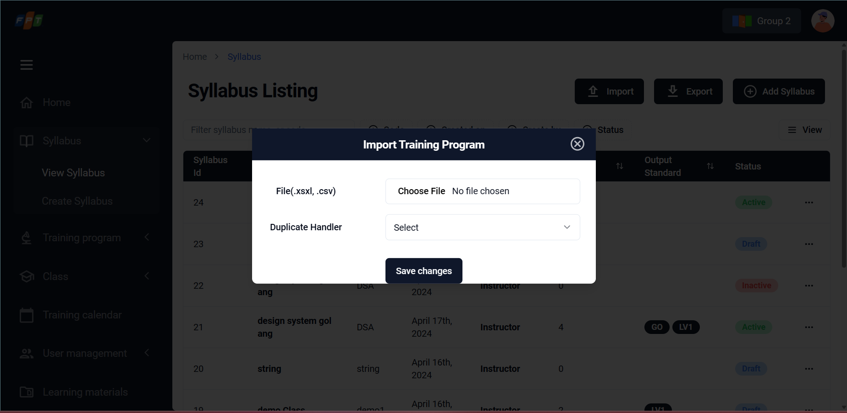

*Figure 18: Import syllabus form*

| **No.** | **Screen element** | **Format Type** | **Require** | **Default show** | **Data type** | **Data table** | **Default value** | **Description** |
| --- | --- | --- | --- | --- | --- | --- | --- | --- |
| 1 | Import Syllabus popup | Pop-up | N/A | Yes | N/A | - | N/A | Import Syllabus pop-up |
| 2 | File (csv) | button | Yes | Yes | Upload file | - | Not selected | Upload file button  Onclick to open browser in device and select CSV file.  Referring to Template_Import_Syllabus file.  Maximum number of file selected: 1 per time  Maximum size of file is 25MB. |
| 3 | Import template | Hyperlink | No | Yes | file | - | Download | Download import template by CSV extension  Downloaded file: Referring to Template_Import_Syllabus file. |
| 4 | Duplicate control - Scanning | Checkbox | No | Yes | checkbox | - | Syllabus code | Choose scanning method (Syllabus code or Syllabus name or both)   * Syllabus code: Only apply for syllabus code (allow (confirming), replace, skip) * Syllabus name: Only apply for syllabus name (allow (confirming), replace, skip) * Both: apply for both syllabus code and name (allow (confirming), replace, skip) |
| 5 | Duplicate control – Duplicate handle | Radio button | No | Yes | Radio | - | Allow | Select duplicate handling (Allow, Replace, Skip)   * Allow: (confirming) * Replace: Replace exitsting file with the latest one. After replace, close the Import pop-up, display a toast message in top of screen “Uploaded file is replaced”, replaced syllabus is moved to the top of the Syllabus list with newest created_date and other related information * Skip: Execute checking duplicate and skip |
| 6 | Cance/ Exist popupl | button | N/A | Yes | N/A | N/A | N/A | User click 'Cancel' or “X” to cancel import syllabus |
| 7 | Import | button | N/A | Yes | N/A | N/A | N/A | Execute importing selected/uploaded CSV file  - Successfully upload: Import pop-up is closed, display List Syllabus screen with a new record is added (sort by created_date in DESC; status is “Draft”; different code)  - Unsuccessfully upload: Import pop-up is stay still and display error  1. File (csv): if there is no upload file. Error message in right under corresponded field EM34 |

### Duplicate syllabus

| **Description** | Allow instructor to create a new syllabus version by cloning the existed one |
| --- | --- |
| **User Story ID** | US15 |
| **As a** | Instructor |
| **I want** | I want to be able to create a new syllabus version by cloning the existed one |
| **So that** | so that I can quickly create a syllabus for the training program and update some of the syllabus content if needed but not cause changes to the original one. |
| **Acceptance Criteria** | AC1: At syllabus detail information screen, when user click on manage syllabus button, User can duplicate syllabus from the current viewing version. After duplicated, move to Syllabus List screen with a new syllabus that added (sorted by created_date in DESC & corresponded syllabus is in “Drafting” mode.  AC2: User can review the syllabus information before submitting duplicating. (Refer 3.2.2. Create Syllabus screen).  AC3: Duplicated version is considered as drafted version of the syllabus. |
| **Message** | N/A |
| **Reference** | UI: [**Figma URL**](https://www.figma.com/file/NQEXjnlUgG5YRvE5KsqtDR/FA_training_system_260822-BA_PRAC_class?type=design&node-id=123552-11728&mode=design) |

#### Screen item description (Refer Figure 12)

### Search syllabus

| **Description** | Menu: Tab Syllabus => View Syllabus => Search |
| --- | --- |
| **User Story ID** | US16 |
| **As a** | Admin |
| **I want** | I want to be able to create a new syllabus version by cloning the existed one |
| **So that** | so that I can quickly create a syllabus for the training program and update some of the syllabus content if needed but not cause changes to the original one. |
| **Acceptance Criteria** | AC1: At syllabus listing screen, User can enter keywords (name) to search the specific syllabus.  AC2: At syllabus listing screen, User can filter by created date, created by, code and status  AC3: Show a dropdown list of matching syllabus names, and codes when typing the search words (limit 10 results).  AC4: If no syllabus matched with search condition, show the empty list and recommend the user to edit the search condition. |
| **Message** | N/A |
| **Reference** | UI: [**Figma URL**](https://www.figma.com/file/NQEXjnlUgG5YRvE5KsqtDR/FA_training_system_260822-BA_PRAC_class?type=design&node-id=123552-11728&mode=design) |

#### Screen item description (Refer Figure 13)

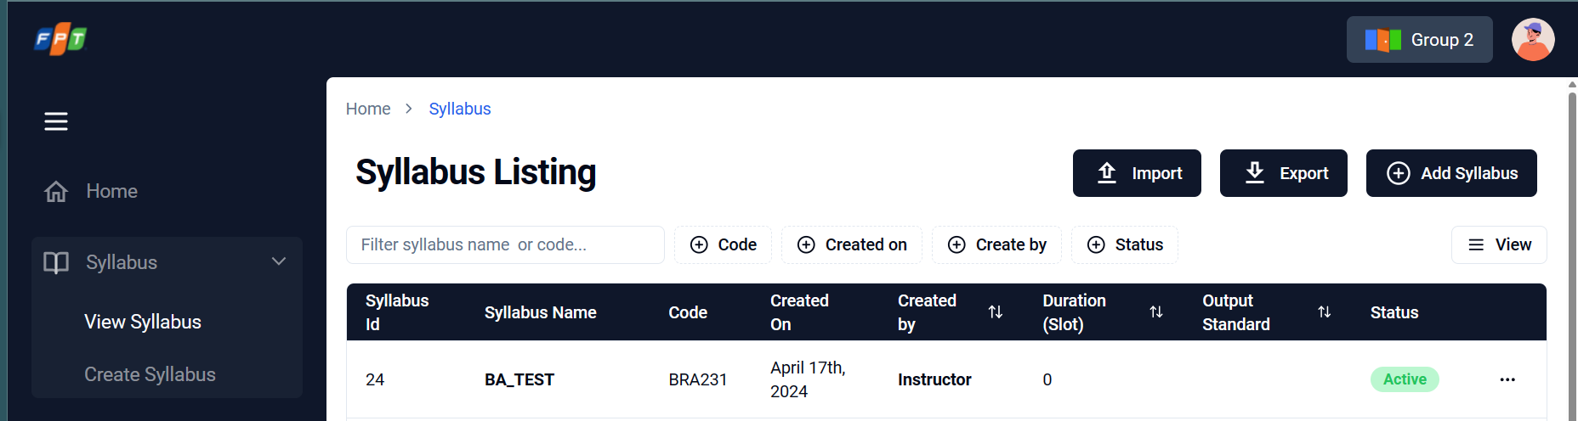

## Management training program

### View list of existed training program/ Training program listing screen

| **Description** | Allow admin/instructor to view list of existed training program / Training program listing screen |
| --- | --- |
| **User Story ID** | US17 |
| **As a** | Admin/Trainer |
| **I want** | I want to be able to view a list of existing training program order by created_date |
| **So that** | so that I can overview all training program from the newest to the oldest and I can easily find and update current training programmes. |
| **Acceptance Criteria** | AC1: The list of fields that should be displayed are:  - From the training program: Name, created_date, created_by, duration, status  AC2: Table list view with default filter:  - training program status in ("Active", "Drafting")  - training program list is ordered by created_date desc  - training program list is limited by 10 items per page (adjustable)  AC3: Training program status includes  - "Drafting" if it is being saved as draft (only for admin view)  - "Active" if it is published (for admin / trainer / trainee view)  - "Inactive" if it is deactive (only for admin view)  AC4: At the training program listing screen, User can sort the training program list by clicking on the sort icon beside the field column name. |
| **Message** | N/A |
| **Reference** | UI: [**Figma URL**](https://www.figma.com/file/6tLNpYrNQwpAr7f4PfRua5/Practical-BA-2023_FAM?type=design&node-id=53-5282&mode=design&t=aztG1gVZYsOnEHcr-0) |

#### Screen item description

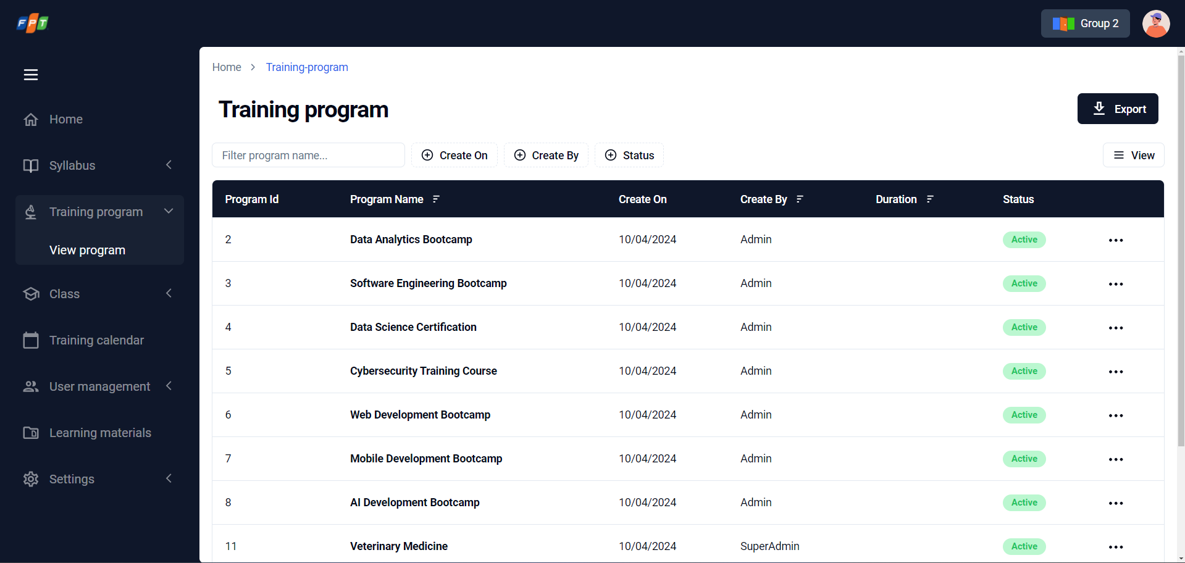

*Figure 19: View list of existed training program / Training program listing screen*

| **No.** | **Screen element** | **Format Type** | **Require** | **Default show** | **Data type** | **Data table** | **Default value** | **Description** |
| --- | --- | --- | --- | --- | --- | --- | --- | --- |
| 1 | Quick search | input | N/A | Yes | text | - | Search by | Allow user input data and search as auto-completed search. Search result will be filtered & displayed as inputted letters |
| 2 | Import | button | N/A | Yes | N/A | - | N/A | Click on button to open import pop-up |
| 3 | Add new | button | N/A | Yes | N/A | - | N/A | Click on button to add a new training program. Move to Create Training program screen |

| **Data Source:** Training_program | | | | | | |
| --- | --- | --- | --- | --- | --- | --- |
| **Filter Condition:** N/A | | | | | | |
| **Sorting By:**  desc by created_date | | | | | | |
| **No** | **Column** | **Group By** | **Sort at header** | **Table/Field** | **Remark** |
| 1 | ID |  | Yes | Training_program .training_program_code | Display corresponding field data |
| 2 | Training program name |  | Yes | Training_program.name | Display corresponding fields data |
| 3 | Created on |  | Yes | Training_program.created_date | Display corresponding fields data |
| 4 | Created by |  | Yes | User.Fullname | Display corresponding field data |
| 5 | Duration |  | Yes | Training_program.duration | Display corresponding field data |
| 6 | Status |  | Yes | Training_program.status | Display corresponding field data |
| 7 | Three dots button | Button | No |  | Allow to open More actions  There are 5 selections   * Training Materials: * Edit training program: onclick to move to corresponded screen of that training program * Duplicate training program: onclick to copy a new training program with same content (but different training program code in DB) * De-active/active training program: onclick to deactive/active corresponded training program * Delete program: inactive due to out-of-scope |

### Create Training program

| **Description** | Allow admin/instructor to create training program |
| --- | --- |
| **User Story ID** | US18 |
| **As a** | Admin |
| **I want** | I want to be able to create a new training program |
| **So that** | so that I can input/store important information and syllabuses of the training program I am going to handle |
| **Acceptance Criteria** | AC1: Required fields: program name, General information, estimated duration, list of syllabuses.  AC2: General information: free inputs.  AC3: User can search and select at least one existing syllabus to add to the program. After added, display outline of syllabus on training program detail programs. Auto get class that assigned to this training program.  AC4: User can select and remove an added syllabus from the program. After remove, syllabus disappear from training program detail  AC5: Users can save a training program as a draft even if they have not fulfilled all required information yet. The drafting training program will have the status = "Drafting".  AC6: After created successful, the status is inactive |
| **Message** | Refer: EM35 to EM38 |
| **Reference** | UI: [**Figma URL**](https://www.figma.com/file/6tLNpYrNQwpAr7f4PfRua5/Practical-BA-2023_FAM?type=design&node-id=56-8406&mode=design&t=aztG1gVZYsOnEHcr-0) |

#### Screen item description (Figure 20, 21, and 22)

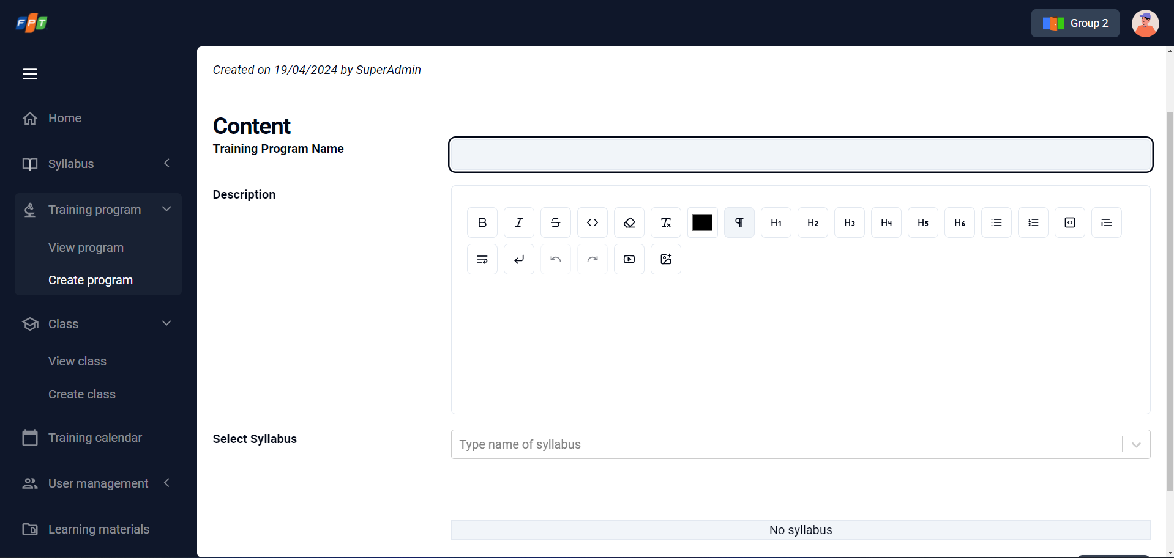

*Figure 20: Create training program_enter program name*

| **No.** | **Screen element** | **Format Type** | **Require** | **Default show** | **Data type** | **Data table** | **Default value** | **Description** |
| --- | --- | --- | --- | --- | --- | --- | --- | --- |
| 1 | Program name | Input | Yes | Yes | Text | Traning_program.name | N/A | Input training program name.  If empty, the system will show the message EM35. |
| 2 | Create | Button | N/A | Yes | N/A | N/A | N/A | Disable when Program name field is empty  Click on -> go to next step of creating training program. |

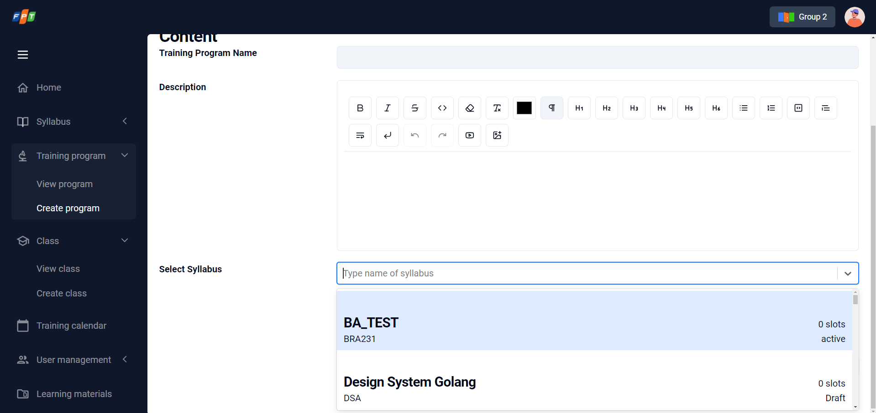

*Figure 21: Create training program_Add syllabus*

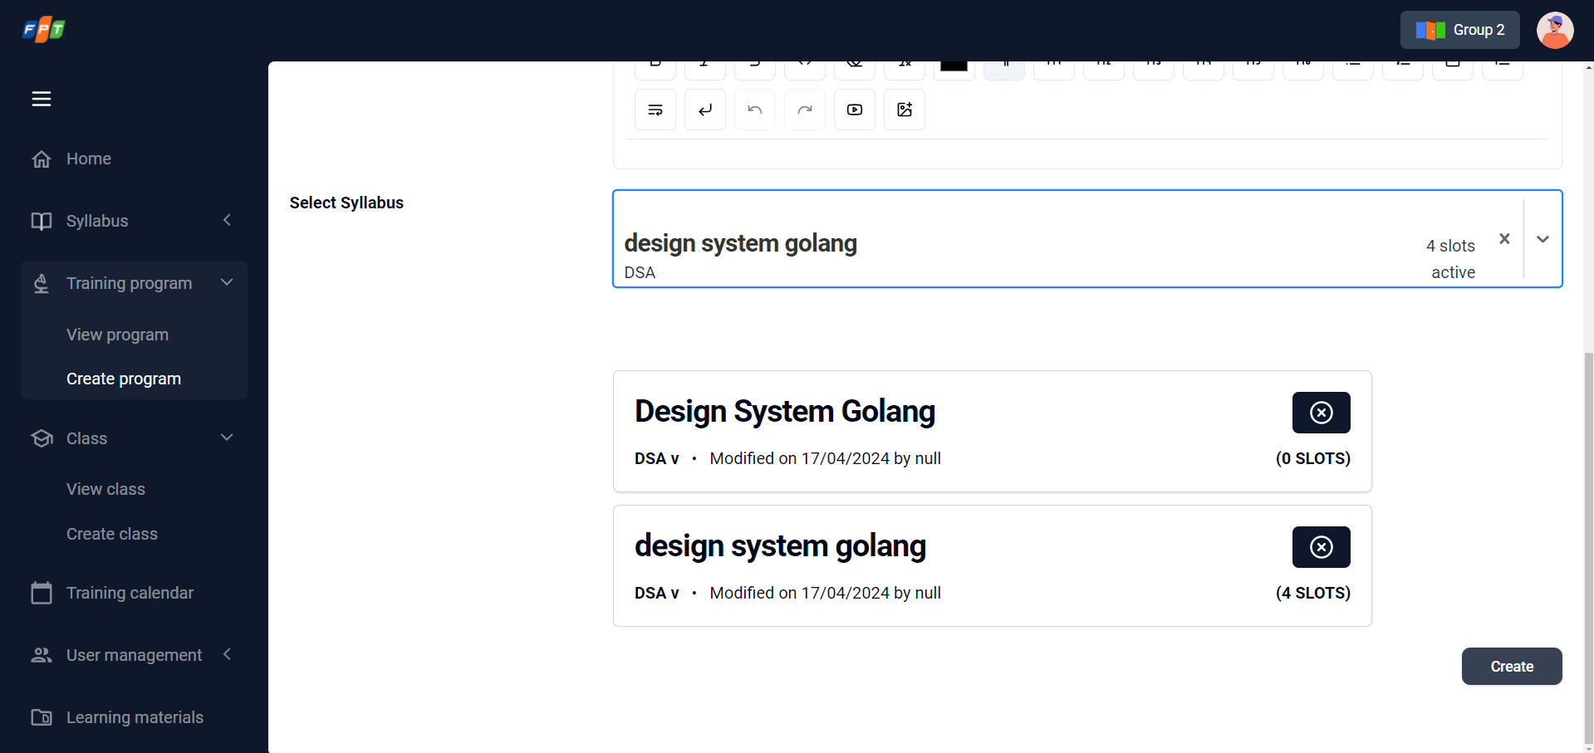

*Figure 22: Create training program_interact with syllabus*

| **No.** | **Screen element** | **Format Type** | **Require** | **Default show** | **Data type** | **Data table** | **Default value** | **Description** |
| --- | --- | --- | --- | --- | --- | --- | --- | --- |
| 3 | Training program name + Status (on header) | Label | N/A | Yes | N/A | Training _program.name & Training_program.status | Inactive | Training program name: get from the previous step, input by creator.  Status : refer to 2.5 State Transition Diagram |
| 4 | …day(…hour) | Label | N/A | Yes | N/A | Training_program.duration | N/A | Total duration from total duration of selected syllabus.  Auto plus when admin add syllabus into training program. |
| 5 | Modified on <create_date> | Label | Yes | Yes | text | - | N/A | Show created date. |
| 6 | By <user_name> | Label | Yes | Yes | Text | - | N/A | User who created training program full name is displayed |
| 7 | General information | input | Yes | Yes | Text area | - | N/A | Allow to input General description of training program.  If empty, the system will show the message EM36. |
| 8 | Search syllabus | Input | Yes | Yes | Text | Trainingprogram_Syllabus.Topic_code & Sequence | Enter syllabus name | Allow user input data and search as auto-completed search. Search result will be filtered & displayed as inputted letters.Sequence = The order of syllabus in Training program saved.  If empty, the system will show the message EM37. |
| 9 | Three dots button | Button | N/A | Yes | N/A | N/A | N/A | Allow to open More actions  There are 5 selections   * Training Materials: interact with materials * Edit training program: onclick to move to corresponded screen of that training program * Duplicate training program: onclick to copy a new training program with same content (but different training program code in DB) * De-active/active training program: onclick to deactive/active corresponded training program * Delete program: inactive due to out-of-scope |
| 10 | Back | button | N/A | Yes | N/A |  | N/A | Click to back the training program list without save the latest update  After clicked, screen moves to training program list |
| 11 | Save | button | N/A | Yes | N/A |  | N/A | Click to save the selected syllabus into new training program  After clicked, screen moves to training program list |
| 12 | Cancel | button | N/A | Yes | N/A |  | N/A | Click to cancel add syllabus into training program  After clicked, screen moves to training program list |
| 13 | Drag for sorting |  | N/A | Yes | N/A | - | N/A | Click and hold a syllabus, move up or down to change position of this syllabus |
| 14 | Content - Title | label | N/A | Yes | N/A | Syllabus.name | N/A | <Syllabus name> input by admin |
| 15 | Content - Status | label | N/A | Yes | N/A | Syllabus.status | N/A | Current status of this syllabus |
| 16 | Content - Version | label | N/A | Yes | N/A | Syllabus.version | N/A | The current version of this syllabus |
| 17 | Content - Modified on <create_date> | Label | Yes | Yes | text | - | N/A | Show created date |
| 18 | Content - By <user_name> | Label | Yes | Yes | Text | - | N/A | User who created training program full name is displayed |
| 19 | Content - …day(…hour) | Label | N/A | Yes | N/A | Training_program.duration | N/A | Total duration from total duration of selected syllabus  Auto plus when admin add syllabus into training program |
| 20 | Content - Remove syllabus | button | N/A | Yes | N/A |  |  | Click to remove a syllabus  After clicked, disappear the syllabus just removed from the list |

### View detail Training Program

| **Description** | Allow admin/trainers/trainee to view detail training program list |
| --- | --- |
| **User Story ID** | US19 |
| **As a** | Admin/trainers/trainee |
| **I want** | I want to be able to read all detail information of the training program |
| **So that** | so that I can view detailed Information, detailed training Materials, included syllabus of the Training Program |
| **Acceptance Criteria** | AC1: User should be able to click on each training program name on training program list to redirect to the training program detail screen  AC2: With the drafting training program, only the admin can see it  AC3: Display fields: program name, General information, estimated duration, list of syllabuses, status, list of classes of training program (for list of classes, only "Active" status for trainees and trainers view, all status for admin view) |
| **Message** | N/A |
| **Reference** | UI: [**Figma URL**](https://www.figma.com/file/6tLNpYrNQwpAr7f4PfRua5/Practical-BA-2023_FAM?type=design&node-id=55-6990&mode=design&t=aztG1gVZYsOnEHcr-0) |

#### Screen item description (Refer Figure 16, 21, 22, and 30)



*Figure 23: Training program detail*

### Update training program information

| **Description** | Allow Admin/instructor to update information of existed training program |
| --- | --- |
| **User Story ID** | US20 |
| **As a** | Admin |
| **I want** | I want to be able to update information of existed training program |
| **So that** | so that I can update the newest and exact information of the training program |
| **Acceptance Criteria** | AC1: The system should allow users to update an existing training program (Status = active)  AC2: Fields can update: General information, estimated duration, list of syllabuses.  AC3: Each time user add/remove syllabus in training program, specific training program will upgrade new version with new list syllabuses  AC4: The changes made to the training program should be saved and reflected in the system. (Add more field: last modified datetime) |
| **Message** | Refer: EM35 to EM38 |
| **Reference** | UI: [**Figma URL**](https://www.figma.com/file/6tLNpYrNQwpAr7f4PfRua5/Practical-BA-2023_FAM?type=design&node-id=56-8406&mode=design&t=aztG1gVZYsOnEHcr-0) |

#### [Screen item description (Refer Figure 22)](https://word-edit.officeapps.live.com/we/wordeditorframe.aspx?ui=en%2DUS&rs=en%2DUS&wopisrc=https%3A%2F%2Ffptsoftware362.sharepoint.com%2Fsites%2FGROUP4_BAPRACTICAL%2F_vti_bin%2Fwopi.ashx%2Ffiles%2F74380ea845d14e9995682d70f4602ad3&wdenableroaming=1&mscc=1&hid=F3F5C4A0-80ED-2000-6C26-415B37777ACD&wdorigin=BrowserReload&jsapi=1&jsapiver=v1&newsession=1&corrid=6eff3e15-6737-4b3a-92ca-5fe15e421999&usid=6eff3e15-6737-4b3a-92ca-5fe15e421999&sftc=1&cac=1&mtf=1&sfp=1&instantedit=1&wopicomplete=1&wdredirectionreason=Unified_SingleFlush&rct=Normal&ctp=LeastProtected#_Screen_item_description)

### Import training program/ training program importing screen

| **Description** | Allow admin to create a new training program through importing CSV/excel file |
| --- | --- |
| **User Story ID** | US21 |
| **As a** | Admin |
| **I want** | I want to be able to create a new training program through importing CSV/excel file |
| **So that** | so that I can save my time to ingest one existed training programmes by CSV/excel file without filling every fields in manually |
| **Acceptance Criteria** | AC1: User can upload Excel/CSV file to create a training program. The imported file has to meet all validation conditions like when creating a new training program or it will generate errors.  AC2: User can download the template of the import file. |
| **Message** | Refer: EM39 |
| **Reference** | UI: [**Figma URL**](https://www.figma.com/file/6tLNpYrNQwpAr7f4PfRua5/Practical-BA-2023_FAM?type=design&node-id=56-8406&mode=design&t=aztG1gVZYsOnEHcr-0) |

#### Screen item description

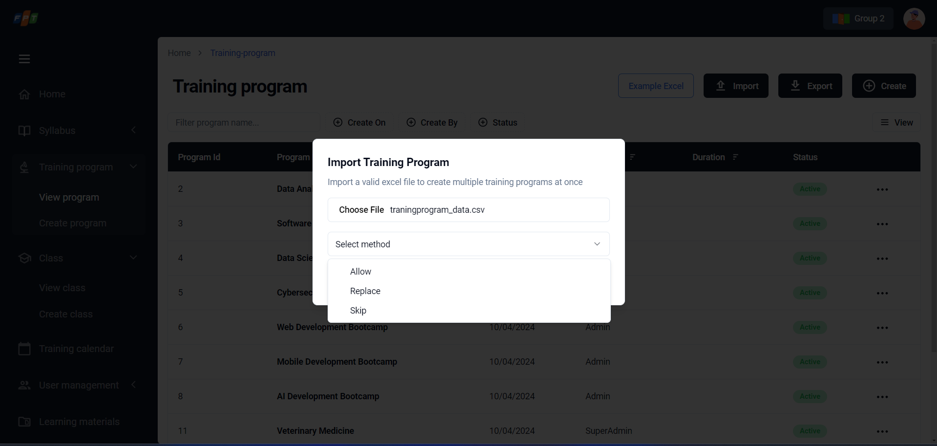

*Figure 25: Import training program form*

| **No.** | **Screen element** | **Format Type** | **Require** | **Default show** | **Data type** | **Data table** | **Default value** | **Description** |
| --- | --- | --- | --- | --- | --- | --- | --- | --- |
| 1 | Import Training program popup | Pop-up | N/A | Yes | N/A | - | N/A | Import Training program pop-up |
| 2 | File (csv) | button | Yes | Yes | Upload file | - | Not selected | Upload file button  Onclick to open browser in device and select CSV file  Maximum number of file selected: 1 per time  Maximum size of file: 25Mb |
| 3 | Encoding type | Dropdown list | No | Yes | selection | - | Auto detect | Select encoding type including Auto detect / ... |
| 4 | Column separetor | Dropdown list | No | Yes | selection | - | Comma | Select separating way including Comma / Dot... |
| 5 | Import template | Hyperlink | No | Yes | file | - | Download | Download import template by CSV extension.  Downloaded file: Referring to Template file. |
| 6 | Duplicate control - Scanning | Checkbox | No | Yes | checkbox | - | Training program code | Choose scanning method (Training program code or Training program name)   * Training program code: Only apply for Training program code (allow (confirming), replace, skip) * Training program name: Only apply for Training program name (allow (confirming), replace, skip) * Both: apply for both Training program code and name (allow (confirming), replace, skip) |
| 7 | Duplicate control – Duplicate handle | Radio button | No | Yes | Radio | - | Allow | Select duplicate handling (Allow, Replace, Skip)   * Allow: (confirming) * Replace: Replace exitsting file with the latest one. After replace, close the Import pop-up, display a toast message in top of screen “Uploaded file is replaced”, replaced Training program is moved to the top of the Training program list with newest created_date and other related information * Skip: Execute checking duplicate and skip |
| 8 | Cancel | button | N/A | Yes | N/A | N/A | N/A | User click 'Cancel' to cancel import training program |
| 9 | Import | button | N/A | Yes | N/A | N/A | N/A | Execute importing selected/uploaded CSV file  - Successfully upload: Import pop-up is closed, display List Training program screen with a new record is added (sort by created_date in DESC; status is “Draft”; different code)  - Unsuccessfully upload: Import pop-up is stay still and display error  1. File (csv): if there is no upload file. Error message in right under corresponded field EM39 |

### Duplicate training program

| **Description** | Allow instructor to create a new training program version by cloning the existed one |
| --- | --- |
| **User Story ID** | US22 |
| **As a** | Instructor |
| **I want** | I want to be able to create a new training program version by cloning the existed one |
| **So that** | so that I can quickly create a training program for the training program and update some of the training program content if needed but not cause changes to the original one. |
| **Acceptance Criteria** | AC1: At training program list screen, when user click on manage training program button, User can duplicate training program from the selected training program.  AC2: At training program detail screen, when user click on Dupblicate User can duplicate training program from the selected training program.  AC3: User can review the training program information before submitting duplicating. (create screen).  AC4: Duplicated version is considered as drafted version of the training program. |
| **Message** | N/A |
| **Reference** | UI: [**Figma URL**](https://www.figma.com/file/6tLNpYrNQwpAr7f4PfRua5/Practical-BA-2023_FAM?type=design&node-id=53-5259&mode=design&t=aztG1gVZYsOnEHcr-0) |

#### Screen item description (Refer [Figure](https://word-edit.officeapps.live.com/we/wordeditorframe.aspx?ui=en%2DUS&rs=en%2DUS&wopisrc=https%3A%2F%2Ffptsoftware362.sharepoint.com%2Fsites%2FGROUP4_BAPRACTICAL%2F_vti_bin%2Fwopi.ashx%2Ffiles%2F74380ea845d14e9995682d70f4602ad3&wdenableroaming=1&mscc=1&hid=F3F5C4A0-80ED-2000-6C26-415B37777ACD&wdorigin=BrowserReload&jsapi=1&jsapiver=v1&newsession=1&corrid=6eff3e15-6737-4b3a-92ca-5fe15e421999&usid=6eff3e15-6737-4b3a-92ca-5fe15e421999&sftc=1&cac=1&mtf=1&sfp=1&instantedit=1&wopicomplete=1&wdredirectionreason=Unified_SingleFlush&rct=Normal&ctp=LeastProtected#_Screen_item_description) 22)

### Active/Deactive training program

| **Description** | Allow instructor to create a new training program version by cloning the existed one |
| --- | --- |
| **User Story ID** | US24 |
| **As a** | Admin |
| **I want** | I want to be able to active/deactive a Training Program |
| **So that** | so that I can control its availability for enrollment by trainees |
| **Acceptance Criteria** | AC1: Acitve/inactive in training program detail screen |
| **Message** | N/A |
| **Reference** | UI: [**Figma URL**](https://www.figma.com/file/6tLNpYrNQwpAr7f4PfRua5/Practical-BA-2023_FAM?type=design&node-id=53-5259&mode=design&t=aztG1gVZYsOnEHcr-0) |

#### Screen item description (Refer Figure 19)

### Search training program

| **Description** | Allow instructor to create a new training program version by cloning the existed one |
| --- | --- |
| **User Story ID** | US25 |
| **As a** | Admin |
| **I want** | I want to be able to search an existed training program by its name |
| **So that** | so that I can finding specific training programs |
| **Acceptance Criteria** | AC1: Users should be able to enter keywords (Training program code or name)  AC2: When the keyword is not matching any record, system will show announcement "There's no record matching with you keyword"  AC3: filters to search for specific information.  AC4: When users select a specific training program from the search results, display the program details. |
| **Message** | N/A |
| **Reference** | UI: [**Figma URL**](https://www.figma.com/file/6tLNpYrNQwpAr7f4PfRua5/Practical-BA-2023_FAM?type=design&node-id=53-5259&mode=design&t=aztG1gVZYsOnEHcr-0) |

#### Screen item description

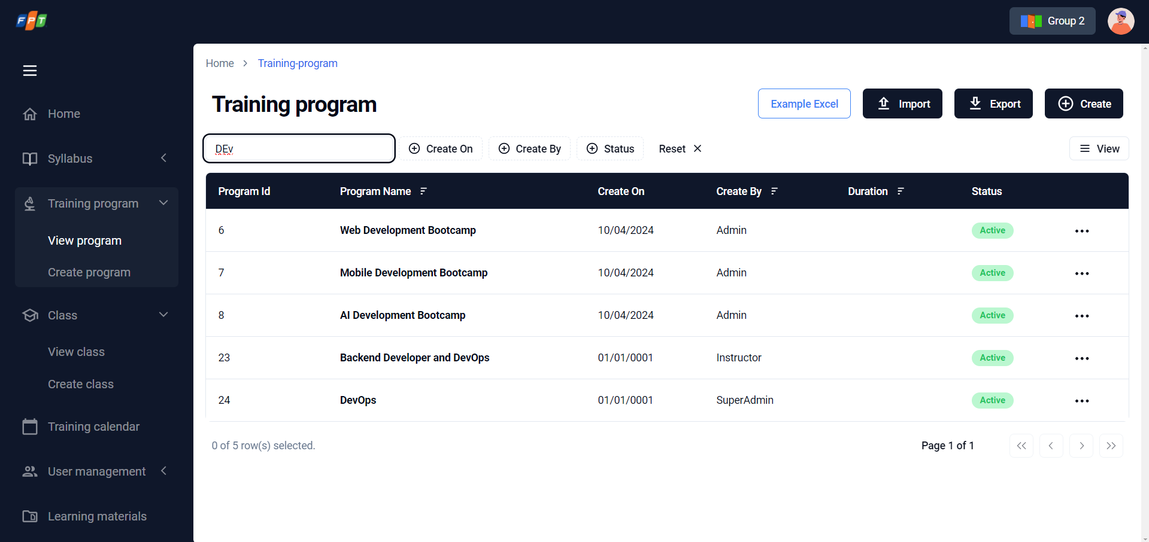

*Figure 26: Search training program*

| **No.** | **Screen element** | **Format Type** | **Require** | **Default show** | **Data type** | **Data table** | **Default value** | **Description** |
| --- | --- | --- | --- | --- | --- | --- | --- | --- |
| 1 | Quick search | input | N/A | Yes | text | - | N/A | Allow user input data and search as auto-completed search. Search result will be filtered & displayed as inputted letters   * If there is no record: display text “Currently no records” * Searched by Program name * Searched conditions will be displayed right under the quick search textbox, as tag with grey color & “x” icon for deleting * Display maximum 4 tags. |
| 2 | Searched condition displaying | chip | N/A | N/A | N/A | - | N/A | Display searched result due to inputted search condition (quick search) |

### Upload training materials

| **Description** | Allow instructor to create a new training program version by cloning the existed one |
| --- | --- |
| **User Story ID** | US25 |
| **As a** | Admin |
| **I want** | I want to be able to upload external training materials into my training programs |
| **So that** | so that I can remove specific learning resources from training programs |
| **Acceptance Criteria** | AC1: User can upload training materials, including documents, videos, images, or other relevant materials.  AC2: Maximum size and Number of files (define later., depend on capacity of system,)  AC3: Display the additional training materials to employees along with the rest of the program details. |
| **Message** | Refer: EM40 to EM41 |
| **Reference** | UI: [**Figma URL**](https://www.figma.com/file/6tLNpYrNQwpAr7f4PfRua5/Practical-BA-2023_FAM?type=design&node-id=53-5259&mode=design&t=aztG1gVZYsOnEHcr-0) |

#### Screen item description

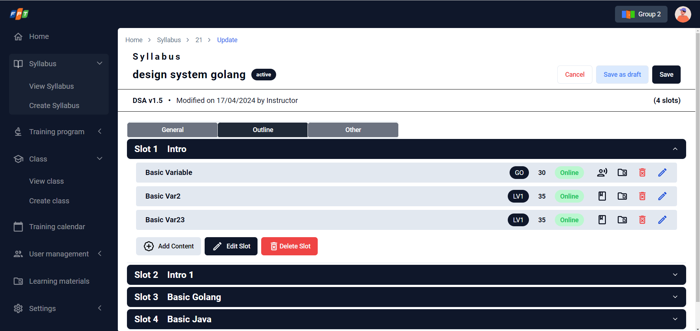

*Figure 27: Upload training materials*

| **No.** | **Screen element** | **Format Type** | **Require** | **Default show** | **Data type** | **Data table** | **Default value** | **Description** |
| --- | --- | --- | --- | --- | --- | --- | --- | --- |
| 1 | Lecture material upload icon | icon | N/A | No | N/A | - | N/A | Onclick to open upload/edit/delete training materials for each lecture |
| 2 | Training material popup - Ⓧ icon | icon | N/A | No | N/A | - | N/A | Onclick for close training material pop-up |
| 3 | Training material popup – Upload new | button | N/A | No | N/A |  | N/A | Open browser to select training materials   * Allowed upload file/extension: image, pdf, ppt, video, xls * Maximum size: 25MB * If the selected file is invalid, the system will show message EM40. |
| 4 | Training material popup – Uploaded file | hyperlink | N/A | No | N/A |  | N/A | Displayed uploaded material files as hyperlink (format: {filename}.{extension})   * Onclick to download file |
| 5 | Training material – uploaded by information | Text | N/A | No | N/A | N/A | N/A | Displayed information of uploaded person & date time (format: by {uploaded person name} on {dd/mm/yyyy} |
| 6 | Training material – edit icon (pencil icon) | icon | N/A | No | N/A | - | N/A | Click to edit/re-upload uploaded file |
| 7 | Training material – delete icon | icon | N/A | No | N/A | - | N/A | Onclick to delete/remove corresponded material file |

### Delete training materials

| **Description** | Allow admin to create a new training program version by cloning the existed one |
| --- | --- |
| **User Story ID** | US26 |
| **As a** | Admin |
| **I want** | I want to be able to delete external training materials into my training programs |
| **So that** | so that I can remove specific learning resources from training programs |
| **Acceptance Criteria** | 'AC1: Display the updated list of training materials to the employee so that they can access and review the relevant materials then select and delete them.  AC2: Display Notify: EM39 when user click delete button.  AC3: Display the updated list of training materials in the training program details. |
| **Message** | Refer: EM39 |
| **Reference** | UI: [**Figma URL**](https://www.figma.com/file/6tLNpYrNQwpAr7f4PfRua5/Practical-BA-2023_FAM?type=design&node-id=53-5259&mode=design&t=aztG1gVZYsOnEHcr-0) |

#### Screen item description (Refer figure 27)

### Download training materials

| **Description** | Allow admin to create a new training program version by cloning the existed one |
| --- | --- |
| **User Story ID** | US27 |
| **As a** | Admin |
| **I want** | I want to be able to download a training material from training programs |
| **So that** | so that I can view, save and check detail of materials |
| **Acceptance Criteria** | AC1: User selects a specific material from the list to download the material to their computer or device and the material should be accessible offline, without requiring an internet connection. |
| **Message** | N/A |
| **Reference** | UI: [**Figma URL**](https://www.figma.com/file/6tLNpYrNQwpAr7f4PfRua5/Practical-BA-2023_FAM?type=design&node-id=53-5259&mode=design&t=aztG1gVZYsOnEHcr-0) |

#### Screen item description (Refer figure 27)

## Class management

### Search class on list

| **Description** | Allow Admin to search on class list |
| --- | --- |
| **User Story ID** | US28 |
| **As a** | Admin |
| **I want** | I want to search on class list by Class code and class name |
| **So that** | so that I can quickly find the information I need |
| **Acceptance Criteria** | AC1: Users should be able to enter keywords (Include: Class code and class name) to search on class list.  AC2: Conditions filter class list include Location (multiple location), Class time frame (From Date - To Date), Class time (Morning, Noon, Night, Online), Status (Planning, Scheduled, Opening, Closed), FSU, Trainer.  AC3: When the keyword or filter is not matching any record, the system will show an announcement "There's no record matching with your keyword. |
| **Message** | N/A |
| **Reference** | UI: [**Figma URL**](https://www.figma.com/file/sMmFYTXZ2stHaEKCG8AlLB/FA_training_system_260822-BA_PRAC_class_Feature-5?type=design&node-id=30%3A73&mode=design&t=iC8yXU5W8bObAbNK-1) |

#### Screen item description

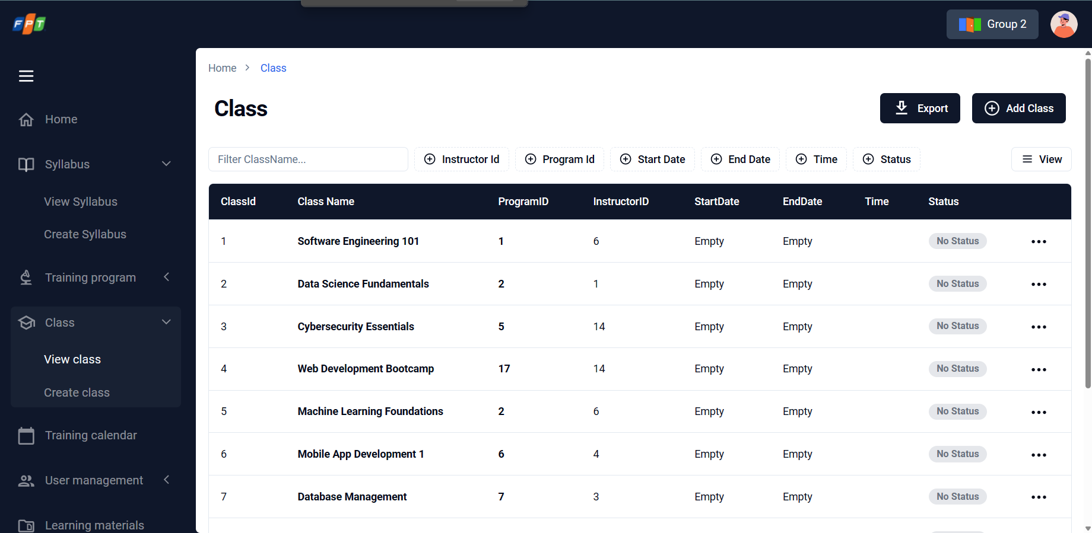

*Figure 28: Class list and search class*

| **No.** | **Screen element** | **Format Type** | **Require** | **Default show** | **Data type** | **Data table** | **Default value** | **Description** |
| --- | --- | --- | --- | --- | --- | --- | --- | --- |
| 1 | Quick search | input | N/A | Yes | text | - | N/A | Allow user input data and search as auto-completed search. Search results will be filtered & displayed as input letters.   * Searched by class name * Searched conditions will be displayed right under the quick search textbox, as tag with grey color & “x” icon for deleting * Display maximum 4 tags |
| 2 | Filter | Button | N/A | Yes | N/A | N/A | N/A | Click on button to open (or close) the popup Search class on list |
| 3 | Searched condition displaying | chip | N/A | N/A | N/A | - | N/A | Display searched result due to inputted search condition (quick search) |

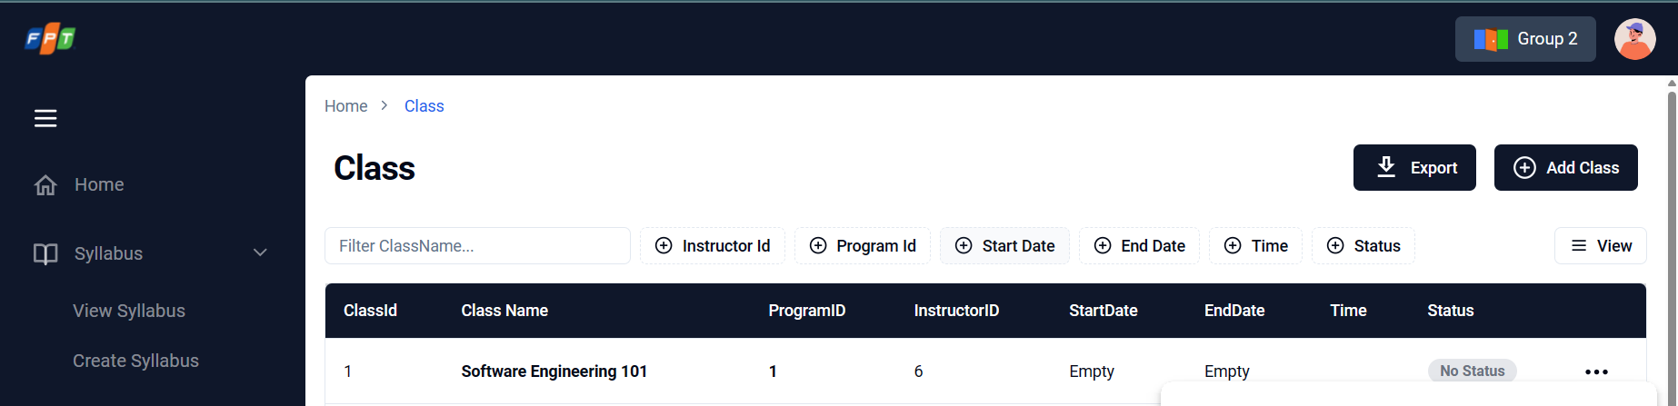

*Figure 29: Search class with filter on list*

| **No.** | **Screen element** | **Format Type** | **Require** | **Default show** | **Data type** | **Data table** | **Default value** | **Description** |
| --- | --- | --- | --- | --- | --- | --- | --- | --- |
| 1 | Class time frame - From | Dropdown List | No | Yes | Date | Class.start_date | Blank | Select the earliest date of starting date (format: mm/dd/yyyy).  If one of the two values is blank, the system defaults to the earliest start date or the latest end date. |
| 2 | Class time frame - To | Dropdown List | No | Yes | Date | Class.end_date | Blank | Select the latest date of ending date (format: mm/dd/yyyy).  If one of the two values is blank, the system defaults to the earliest start date or the latest end date. |
| 3 | Class time | Check box | No | Yes | Option | N/A | N/A | Allow select Class time for the search condition  User can choose multiple value. |
| 4 | Status | Check box | No | Yes | Option | N/A | N/A | Allow select Status for the search condition including Planning / Opening / Closed.  User can choose multiple value. |
| 5 | Instructor | Dropdown list | No | Yes | N/A | Class User | Blank | Allow select instructor for the search condition from inputted instructor list (Sorting: Alphabetic order) |
| 6 | Clear | Button | N/A | Yes | N/A | N/A | Disable | Allow clear all the conditions above.  If at least one of the fields in the filter is filled, the button is enabled. |
| 7 | Search | Button | N/A | Yes | N/A | N/A | N/A | Allow filter Class list with the search condition above.  If at least one of the fields in the filter is filled, the button is enabled. |

### View list of class

| **Description** | Allow Admin to view list of class |
| --- | --- |
| **User Story ID** | US29 |
| **As a** | Admin |
| **I want** | I want to view list of class |
| **So that** | so that I can have an overview of all class records and access their details easily |
| **Acceptance Criteria** | AC1: The list of fields that should be displayed are Class code, Class name, Duration (No. of days from start date to end date), Status, instructor, Program.  AC2: The list will show default by these rules:   * Default filter status (Planning, Scheduled, Opening) * Default sorting by alphabet * Default No.of records: 10 records   AC3: User can choose to delete or edit specific record class on list  AC4: Users should be able to access view the details of each class if user double click records on list  AC5: User can choose maximum records on 1 page (10, 50, 100)  AC6: User can choose next page or previous page of class list  AC7: User can choose specific page to view class list |
| **Message** | N/A |
| **Reference** | UI: [**Figma URL**](https://www.figma.com/file/sMmFYTXZ2stHaEKCG8AlLB/FA_training_system_260822-BA_PRAC_class_Feature-5?type=design&node-id=30%3A73&mode=design&t=iC8yXU5W8bObAbNK-1) |

#### Screen item description

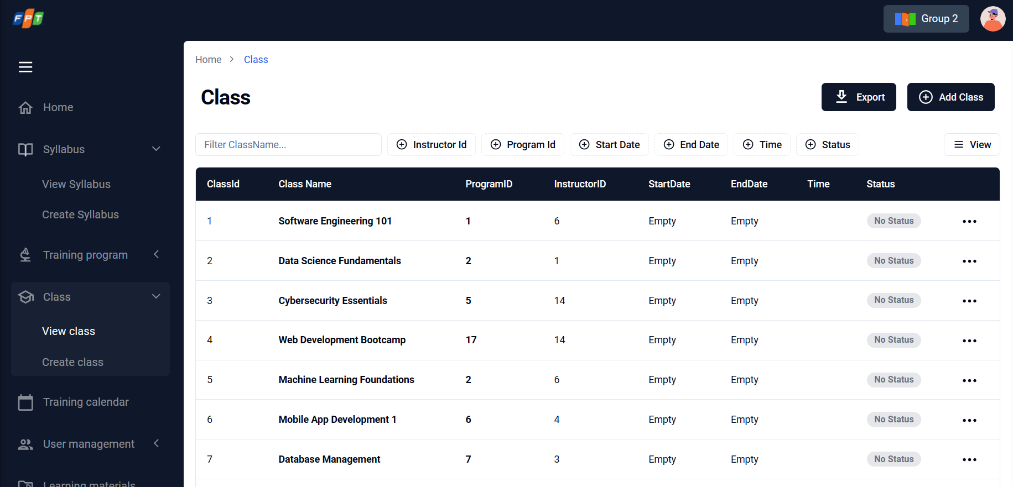

*Figure 30: List of class*

| **No.** | **Screen element** | **Format Type** | **Require** | **Default show** | **Data type** | **Data table** | **Default value** | **Description** |
| --- | --- | --- | --- | --- | --- | --- | --- | --- |
| 1 | Class | Label | N/A | Yes | N/A | Class.class_name | N/A | Class name is displayed and ordered by status (from up to down are Planning / Opening / Closed respectively).   * If there is no record: display text “Currently no records” |
| 2 | Program | Label | N/A | Yes | N/A | Class.ProgramId | N/A | Program for each class |
| 5 | Duration (Class Time) | Label | N/A | Yes | N/A | Class.duration | N/A | Duration of class is displayed (format: {integer number} days) |
| 6 | Attendee | Label | N/A | Yes | N/A | Class.attendee | N/A | Attendee type of class is displayed (format: Intern / Fresher / Online fee-fresher / Offline fee-fresher as tag) |
| 9 | Three dots button | Button | N/A | N/A | N/A | - | N/A | Popup-menu icon is displayed. There are 2 selections   * Edit class: onclick to move to corresponded screen of that class. (refer to US32~US34) * Change Status class: refer to US35. * Delete Class: Remove from server |

### Create class

| **Description** | Allow Admin to create a new class such as training program, list of candidates,instructor, list of syllabuses |
| --- | --- |
| **User Story ID** | US30 |
| **As a** | Admin |
| **I want** | I want to create a new class such as training program, list of candidates, trainer, list of syllabuses. |
| **So that** | so that I can run created class |
| **Acceptance Criteria** | AC1: When class is saved, Class code will be generated by rule: <<Location Code>>+<<Current Year(yy)>>+<<Incremental Number (01-99)>>  AC2: Users should be able to choose these information   * Class name * Training program + Syllabus (reference user story) * General information (Class time from, to of each semester, Slot, ,Location ,Instructor, Admin) * Training calendar by day   AC3: The info below should be mandatory: Class name, General information (Class time from, to of each semester, Slot, ,Location ,Instructor, Admin), Training calendar by day  AC4: The created class can be saved as draft (Status = InActive) and accessible for future to update final |
| **Message** | Refer: EM41 to EM48. |
| **Reference** | UI: [**Figma URL**](https://www.figma.com/file/sMmFYTXZ2stHaEKCG8AlLB/FA_training_system_260822-BA_PRAC_class_Feature-5?type=design&node-id=30%3A73&mode=design&t=iC8yXU5W8bObAbNK-1) |

#### Screen item description

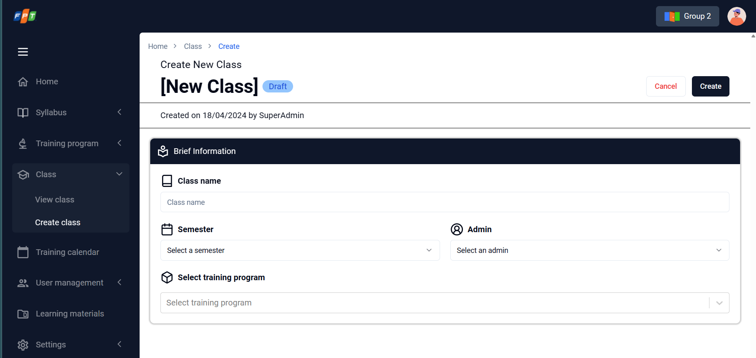

*Figure 31: Create class general*

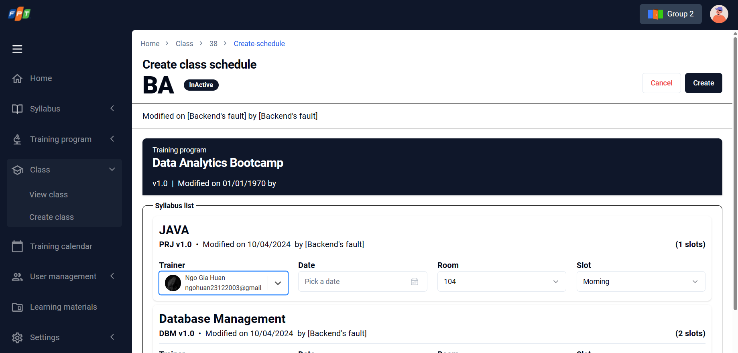

*Figure 32: Create class detail*

| **No.** | **Screen element** | **Format Type** | **Require** | **Default show** | **Data type** | **Data table** | **Default value** | **Description** |
| --- | --- | --- | --- | --- | --- | --- | --- | --- |
| 1 | Class | Header | N/A | Yes | N/A | N/A | N/A | N/A |
| 2 | Class name | input | Yes | Yes | Text | Class.class_name | N/A | Input class name.  If empty, the system will show the message EM41. |
| 3 | Create | button | N/A | Yes | N/A | N/A | N/A | Disable when Class name field is empty  Click on -> go to next step of creating class. |

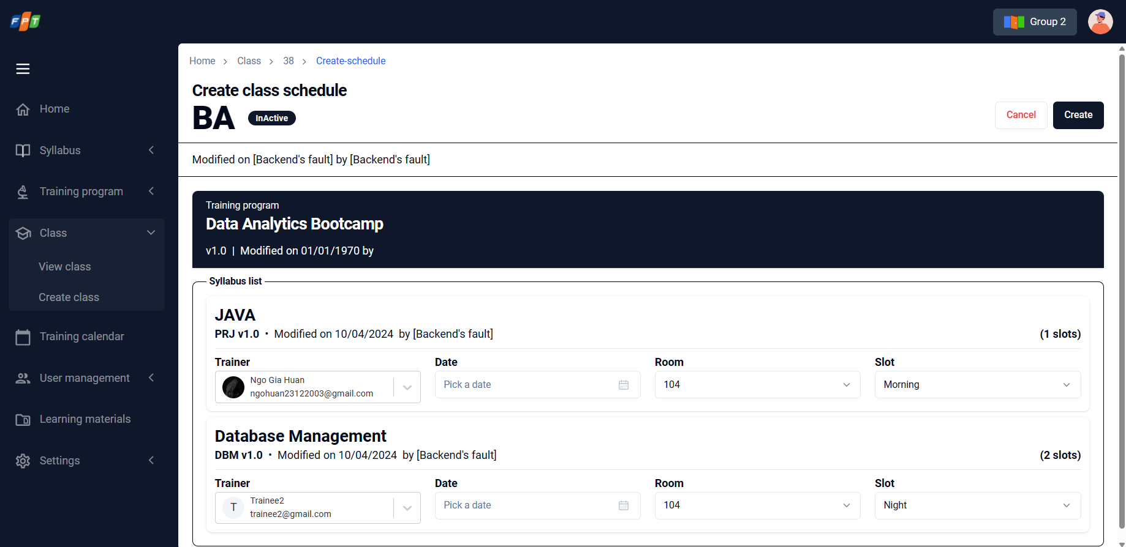

*Figure 32: Create class_Add training program*

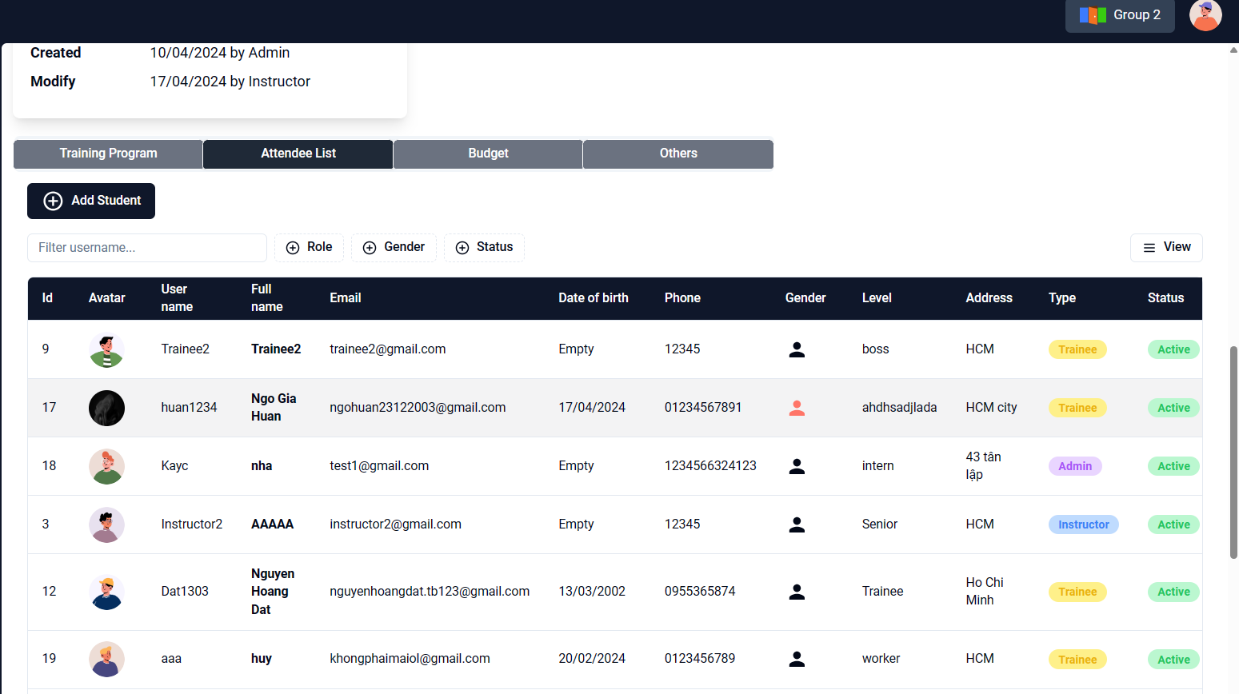

*Figure 32.1: Create class_Add Attendee*

| **No.** | **Screen element** | **Format Type** | **Require** | **Default show** | **Data type** | **Data table** | **Default value** | **Description** |
| --- | --- | --- | --- | --- | --- | --- | --- | --- |
| 1 | Class name + Status (on header) | Label | N/A | Yes | N/A | Class.name, Class.status | Planning | Class name: get from the previous step, input by creator  Status: refer to 2.5 State Transition Diagram |
| 2 | …day (…hour) | Label | N/A | Yes | N/A | Training_program.duration | N/A | Total duration from total duration of selected syllabus.  Auto plus when admin add syllabus into training program. |
| 3 | Three dotsx button | Button | N/A | Yes | N/A | - | N/A | Popup-menu icon is displayed. There are 2 selections   * Edit class: onclick to move to corresponded screen of that class. (refer to US32~US34) * Change Status of class: onclick to change status with 2 status including Active or InActive * Delete class: onclick to delete corresponded class (refer to US35). |
| 4 | General | Division | N/A | Yes | N/A | - | N/A | General class information is displayed.  Only expand and enable after inputting training program. |
| 5 | General – Class time | Time picker | N/A | Yes | N/A | - | Blank | Format: From HHMM To HHMM  Allow user input Class time including Time from & Time to.  If empty, the system will show the message EM42. |
| 6 | General - Location (Room) | Dropdown list | No | Yes | N/A | Class.location | Blank | Allow user choose location from the location list. (Sorting: Alphabetic order).  If empty, the system will show the message EM43. |
| 7 | General - Instructor | Dropdown list | No | Yes | N/A | ClassUser.UserID | Blank | Allow user input Admin from the list of Full name of all members with “Role” = “Trainer”. (Sorting: Alphabetic order).  Save with UserType = Admin.  If empty, the system will show the message EM44. |
| 8 | General - Admin | Dropdown list | No | Yes | N/A | ClassUser.UserID | Blank | Allow user input Admin from the list of Full name of all members with “Role” = “Admin”. (Sorting: Alphabetic order).  Save with UserType = Admin.  If empty, the system will show the message EM45. |
| 9 | General - FSU | Dropdown list | No | Yes | N/A | Class.FSU | Blank | Allow user input FSU from the FSU list. (Sorting: Alphabetic order).  If empty, the system will show the message EM46. |
| 10 | General - Created | Label | N/A | Yes | N/A | N/A | Disable |  |
| 11 | General - Review | Label | N/A | Yes | N/A | N/A | Disable |  |
| 15 | Attendee | Dropdown list | No | Yes | N/A | User | Blank | Allow user choose Attendee type of class including Intern / Fresher / Online fee-fresher / Offline fee-fresher.  Only expand and enable after inputting training program. |
| 17 | Attendee - Accepted | Input | N/A | Yes | Number | N/A | Blank | Allow user to input accepted attendee number. |
| 18 | Attendee - Actual | Input | N/A | Yes | Number | N/A | Blank | Allow user to input actual attendee number. |
| 19 | Expand/Collapse icon | icon | N/A | Yes | N/A | N/A | N/A | Allow expand or collapse the divisions |
| 20 | Search training program | Input | Yes | Yes | Text | N/A | Enter training program name | Allow user input data and search as auto-completed search. Search result will be filtered & displayed as inputted letters.  If empty, the system will show the message EM48. |
| 21 | Back | button | N/A | Yes | N/A |  | N/A | Click to back the class list without save the latest update.  After clicked, screen moves to class list. |
| 22 | Cancel | button | N/A | Yes | N/A |  | N/A | Click to cancel adding class.  After clicked, screen moves to class list |
| 23 | Save as draft | button | N/A | Yes | N/A |  | N/A | Click to save and move to class list. |
| 24 | Next | button | N/A | Yes | N/A |  | N/A | Click to save and move to the next tab. |

### View class details

| **Description** | Allow Admin to view detail of class such as training program, list of candidates,instructor, list of syllabuses |
| --- | --- |
| **User Story ID** | US31 |
| **As a** | Admin |
| **I want** | I want to view detail of class such as training program, list of candidates, trainer, list of syllabus |
| **So that** | so that I can review detail of this class |
| **Acceptance Criteria** | AC1: User can see this information of class:  - Class name  - Training program + Syllabus (reference user story)  - General information (Class time “from, to” of each semester, Location,instructor, Admin, FSU)  - Training calendar by day  - No.of Attendees (No. of Planned, No. of Accepted, No. of Actual)  AC2: User can choose "Edit" to update information (Status = "Active" or “InActive") |
| **Message** | N/A |
| **Reference** | UI: [**Figma URL**](https://www.figma.com/file/sMmFYTXZ2stHaEKCG8AlLB/FA_training_system_260822-BA_PRAC_class_Feature-5?type=design&node-id=1278-8615&mode=design&t=3mTT2eRhOJYoqNkl-0) |

#### Screen item description

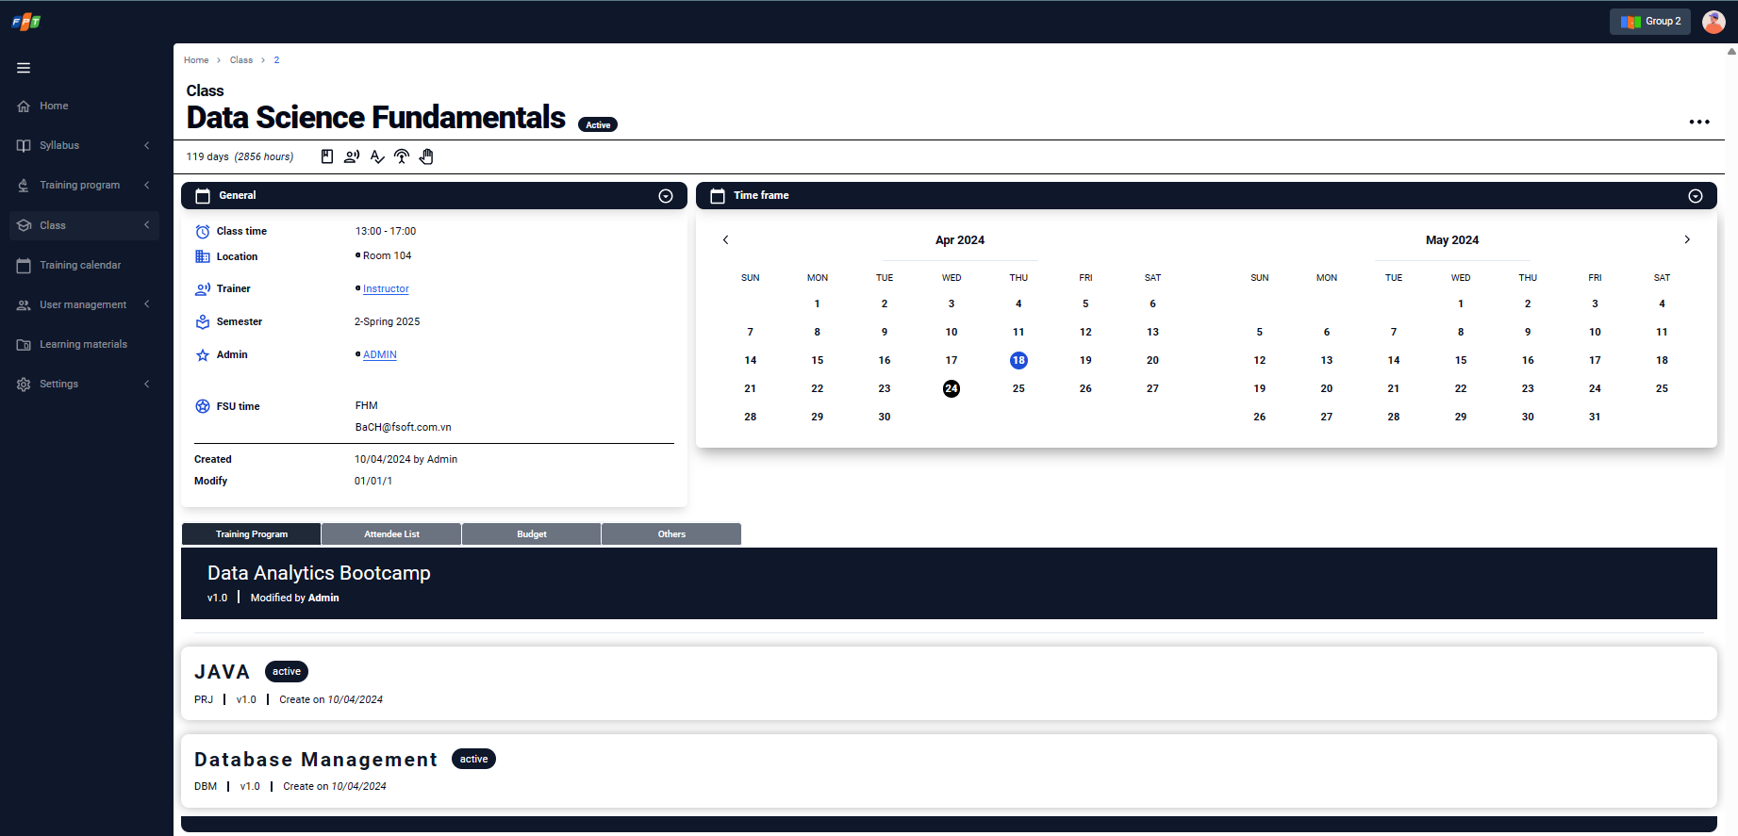

*Figure 33: View class detail*

### Deactivate class

| **Description** | Allow Admin to deactivate class on class list |
| --- | --- |
| **User Story ID** | US35 |
| **As a** | Admin |
| **I want** | I want to deactivate class on class list. |
| **So that** | so that the list will show all useable class. |
| **Acceptance Criteria** | AC1: User can choose to deactivate the class that Status = Active  AC2: When user chooses to deactivate, the system will show a popup  AC3: If user choose "Confirm" on AC2, system will update status of this class into “Deactive”. |
| **Message** | Refer: EM50 |
| **Reference** | UI: [**Figma URL**](https://www.figma.com/file/sMmFYTXZ2stHaEKCG8AlLB/FA_training_system_260822-BA_PRAC_class_Feature-5?type=design&node-id=3-37&mode=design&t=bKo8T68mQz8D2sJi-0) |

#### Screen item description

Refer to **US30: Create class**

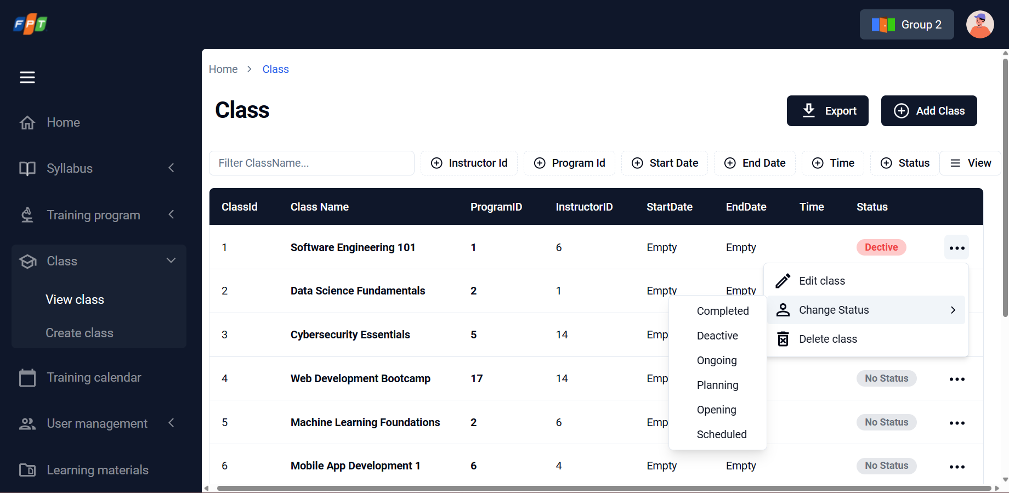

*Figure 34: Delete class*

### View training calendar

| **Description** | Allow Admin to view schedule by each class via training calendar |
| --- | --- |
| **User Story ID** | US37 |
| **As a** | Admin |
| **I want** | I want to view schedule by each class via training calendar. |
| **So that** | So that I can have an overview schedule for specific class. |
| **Acceptance Criteria** | AC1: User can choose 2 modes to view calendar: Day or Week  AC2: Show calendar default by these conditions:   * Default mode = Day * Default date = Current Date   AC3: In Day mode of AC1, user can choose specific day to see overview schedule include this information:   * Time range 8h-22h * Split 3 shift: Morning (8h-12h), Noon (13h - 17h) and Night (18h-22h) * Each session of class: Class code, class name, Day of Class location, trainer, admin, time range   AC4: In Week mode of AC1, user can choose specific week to see overview schedule include this information:   * Show days of week (Monday to Sunday) Time * Time range 8h-22h * Split 3 shift: Morning (8h-12h), Noon (13h - 17h) and Night (18h-22h) * Each session of class: Class code, class name, Day of Class location, trainer, admin, time range. |
| **Message** | N/A |
| **Reference** | UI: [**Figma URL**](https://www.figma.com/file/sMmFYTXZ2stHaEKCG8AlLB/FA_training_system_260822-BA_PRAC_class_Feature-5?type=design&node-id=164-4346&mode=design&t=bKo8T68mQz8D2sJi-0) |

#### Screen item description

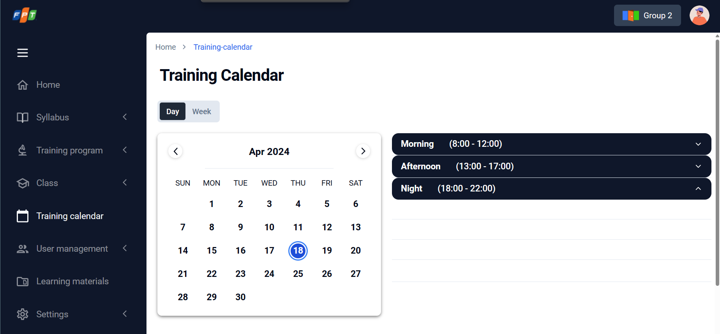

*Figure 35: View schedule by dayvia training calendar*

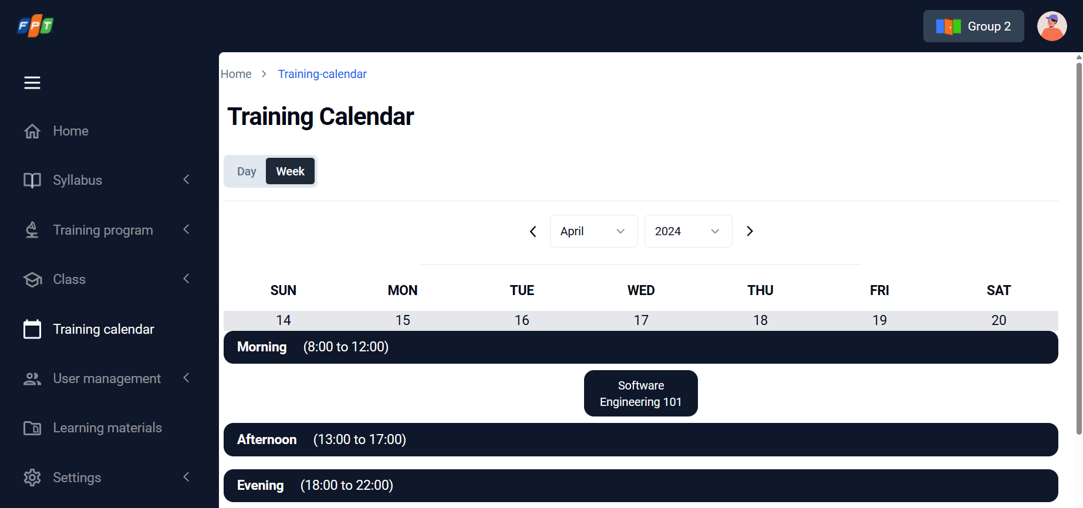

*Figure 36: View schedule by each class via training calendar*

| **No.** | **Screen element** | **Format Type** | **Require** | **Default show** | **Data type** | **Data table** | **Default value** | **Description** |
| --- | --- | --- | --- | --- | --- | --- | --- | --- |
| 1 | Training Calendar | Label | N/A | Yes | N/A | N/A | N/A | Header |
| 2 | Day | Calendar | N/A | Yes | N/A | Class | N/A | Display searched results in format of weekly calendar distributed into time frame such as Morning / Noon / Night.  Training schedule of each class has its own color.  Only display the class code_content name. |
| 3 | Week | Time Calendar | N/A | Yes | N/A | Class | N/A | Display searched results in format of daily calendar distributed into time frame such as Morning / Noon / Night.  Training schedule of each class has its own color.  Only display the class code, content name.  Onclick to display the day of progress, location, trainer, admin. |
| 4 | Date Range | Calendar | N/A | Yes | N/A | Class | N/A |  |

## 3.5. Error message

| **No.** | **Screen Name** | **Error Message** |
| --- | --- | --- |
| EM01 | Create/update user | User type is required. |
| EM02 | Name is required. |
| EM03 | Email address is required. |
| EM04 | Email address is existed. Please check and input another email address. |
| EM05 | Email address is invalid. Please check and input again. |
| EM06 | Phone is required. |
| EM07 | Phone is invalid. Please check and input again |
| EM08 | Date of birth is required. |
| EM09 | User is created successfully. |
| EM10 | User is updated successfully. |
| EM11 | Update role permission | Role is updated successfully. |
| EM12 | Create syllabus(general) | Syllabus name is required. |
| EM13 | Level is required. |
| EM14 | Attendee number is required. |
| EM15 | Technical requirement(s) is required. |
| EM16 | Course objectives are required. |
| EM17 | Create syllabus(outline) | Unit name is required. |
| EM18 | Content name is required. |
| EM19 | Output standard is required. |
| EM20 | Training time is required. |
| EM21 | Delivery type is required. |
| EM22 | Delete all content of the Day? |
| EM23 | Please input at least one day. |
| EM24 | Please input at least one unit into this day. |
| EM25 | Please input at least one content into this unit. |
| EM26 | The duration exceeds 8 hours per day. Please check again. |
| EM27 | Create Syllabus (Others- Assessment scheme) | Quiz is required. |
| EM28 | Assignment is required. |
| EM29 | Final is required. |
| EM30 | Final Theory is required. |
| EM31 | Final Practice is required. |
| EM32 | GPA is required. |
| EM33 | Total of all assessment is not 100%. Please check again. |
| EM34 | Import syllabus | File is required. |
| EM35 | Create training program | Program name is required. |
| EM36 | General information is required. |
| EM37 | Syllabus is required. |
| EM38 | List of syllabuses is required. |
| EM39 | Import training program | File is required. |
| EM40 | Update training material | File is invalid. Please check and upload again. |
| EM41 | Create class | Class name is required. |
| EM42 | Class time is required. |
| EM43 | Location is required. |
| EM44 | Trainer is required. |
| EM45 | Admin is required. |
| EM46 | FSU is required. |
| EM47 | Time frame is required. |
| EM48 | Training program is required |
| EM49 | Update class | If you change training program, list of syllabuses will be replaced by new training program |
| EM50 | Delete class | Do you want to delete <class name> class? |
| EM51 | Update training calendar | Do you want to update schedule?  This session of class only.  All Session of this class. |

# Other Function Specifications

## Rule for syllabus version

Currently, we are using this format to generate syllabus version: i1.i2.i3

* i1: represents the major version number of the syllabus. It is manually changeable by the user and is used for significant updates or revisions to the syllabus content. The default value of i1 is 1.
* i2: denotes the published version number of the syllabus. This version number is automatically generated by the system when the syllabus is published or made available to users. It serves as a reference for the currently active and accessible version of the syllabus.
* i3: signifies the drafted or duplicated version number of the syllabus. The system auto-generates i3 when a new version of the syllabus is created for drafting or duplication purposes. It helps to differentiate between the main published version and any draft or duplicated versions that may exist in the system.

## Rule for Training Program Version

* Updating a Training Program:
* When a user updates an existing Training Program, the system increments the version number by 1.
* The updated version number reflects the changes made to the Training Program and helps track the progression of revisions.
* For example, if the original Training Program version was 1, the updated version would become 2.
* Creating a New Training Program by Duplicating an Existing One:
* When a user creates a new Training Program by duplicating an existing one, the system assigns a new version number based on the original Training Program.
* The new version number indicates that it is a duplicate or draft version of the original Training Program.
* Typically, the system increments the version number by a decimal point or a sub-version number to differentiate it from the original Training Program.
* For example, if the original Training Program version was 3, the duplicated version may be assigned as 3.1 or 3.0.1.

# Other requirements

## Common field controls

### Free text (Single line of text)

* All free text (single line of text input) displayed in the application, unless otherwise stated, has max length of 255 characters. This includes all text fields & standard search boxes. Once 255 characters have been inputted into the field, additional input is no longer received (not receiving input despite button pressed).
* This input only accepts ASCII characters, and does not accept special character types (e.g. Unicode).

### Option Set

* Selection: Users can choose an option from a list of predefined choices provided by the option set. This allows for accurate and consistent selection of values based on the available options.
* Dropdown or Selection Menu: The option set typically appears as a dropdown or selection menu, displaying the available options in a concise and easily accessible format. Users can click or interact with the menu to view and select the desired option.
* Single or Multiple Selection: Depending on the context and requirements, an option set can support either single selection or multiple selections. In single selection, users can choose only one option from the set, while in multiple selection, users can choose multiple options simultaneously.
* Default Value: An option set often includes a default value, which is automatically preselected when the form or input field is loaded. This provides a convenient starting point for users and improves the user experience by reducing the need for manual selection in common scenarios.
* Dynamic Options: In some cases, the options within an option set may be dynamically populated based on certain conditions or data sources. This allows for dynamic updates and adaptability of the available choices based on changing circumstances.
* Validation: Option sets can include validation mechanisms to ensure that users select a valid option. This helps maintain data integrity and prevents invalid or inconsistent selections.

### Special Text

| **Name** | **Description** | **Max length** | **Example** |
| --- | --- | --- | --- |
| User ID | For AD user | 150 |  |
| Password | * Minimum of 8 characters * Contain at least 1 upper case character (A-Z) * Contain at least 1 lower case character (a-z) * Contain at least 1 numerical number (0-9) * Contain at least 1 special character from the list (_, #, ?, !, @, $, %, ^, &, *, -) * Cannot contain more than 2 consecutive characters from username and/or name of the user. | 12 |  |
| Search bar |  | 255 |  |
| Comments | Input box | 120 |  |
| Email address | xyz@email.com | 150 |  |
| Contact number | 0xxxxxxxxx | 20 |  |
| Date | DD/MM/YYYY | - |  |

### Search bar

* Text Input: The search bar allows users to input text, keywords, or search queries that represent the information they are seeking.
* Auto-suggestions: As users type in the search bar, the system may provide real-time auto-suggestions based on previously entered queries or popular search terms. This feature helps users by offering relevant suggestions and facilitating quicker search entry.
* Search Execution: When users submit their search query, the search bar triggers a search operation within the application. It initiates the process of searching for matching results based on the provided keywords or criteria.
* Result Display: The search bar displays the search results in a structured format, presenting relevant information that matches the user's search query. It may include titles, summaries, snippets, or thumbnails of the matching content.

### Drop-down list

* Auto focus and display the selected value when clicked to show value list.
* Default text when there is no selected value: “Please select <field name>”.
* Display 5 records, if there are more than 5, show vertical scrollbar.
* Sorted alphabetically.
* When the text to be displayed (in each entry, and also in the field after value has been selected) is longer than the text display box, cut the text at the end of first line, and replace the missing characters with “…”. Also applicable with text suggestion during Brand input.
* Show tooltip to when hovering the text to display full text.
* Does not allow duplicate entries.
* Auto focus and display the selected value.
* When parent category is selected, the value list of child category will be displayed.
* Sort by alphabet order.
* Display 6 records, if there are more than 6, show vertical scrollbar.
* When click again to a selected value, reload the selection of category tree. Select on the selected value and all its child category will be non-selected.

### Image attachment

* Allow select and upload 1 image at a time.
* When selecting another image to upload, this will overwrite the old image.
* After image is uploaded, display the image as thumbnail above the button.
* Allow only image file:
* Bitmap (.bmp)
* JPEG (.jpg, .jpeg)
* PNG (.png)
* GIF (.gif)
* User can delete uploaded image by click on option to delete it.
* Maximum allowed size: 5MB, show message “Maximum image attachment size is 5MB.” under the field when user uploaded an image which its size over 5MB.

### Rich text

* Allow copy and paste with html format.
* Allow to format text with header.
* Allow format text as:
* Bold
* Italic
* Underline
* Strikethrough
* Allow text alignment.
* Right
* Left
* Middle
* Allow change text color.
* Allow bulleted list, numbered list.
* Allow attach link (URL hyper link).
* Anchor Link
* URL
* Mail Link
* Allow “Block Quote”
* Allow insert image
* Allow insert table.
* Show tooltip when hover to each action
* Allow user edit and format using keyboard.

### Date picker

* Validate immediately after lost focus.
* Format MM/DD/YYYY
* Show message “The format is invalid.” under the field if user inputted date value with wrong format.
* Place holder: MM/DD/YYYY
* Default value when clicking on :<<Today>>.

### Label Display

* When the text to be displayed is longer than the text display box (Width), move the redundancy to the line under. When move the text to new line, keep the whole word.
* When the text to be displayed is longer than the text display box (Height), cut the text at the end of last line, and replace the missing characters with “…”.
* When the text to be displayed is longer than the text display box (Width) in case of display only one line, replace the missing characters with “…”.
* Show tooltip to when hovering the text to display full text.

### Message configuration

* In-field error messages: Displayed in red italic text.
* All pop-up messages: Always displayed with an “X” button on the top-right corner of the pop-up. Clicking outside of the pop-up does not close it, only the “X” button or respective buttons on the pop-up does.
* After close popup, return to the current webpage.

### View columns display

Unless otherwise stated, view columns’ display specifications are:

* Displayed color & fonts are as specified in approved screen designs.
* When the text to be displayed is longer than the width of cell, cut the text at the end of first line, and replace the missing characters with “…”. Hovering mouse over this “…” will pop up a tooltip at mouse position that displays full content of the respective cell.

Unless otherwise stated, view columns’ headers are:

* Default sorted bases on specific screens.
* When unsorted, show icon as follows: 
* When sorted, show icon as follows: 

### Pagination

Unless stated otherwise, search-related behavior in all views of the system will follow the following specifications:

* When user perform a new search (both completely new and searching within the current search results), refresh table, go back to page 1.
* When user changes the pagination setting (number of items to show per page), refresh table, go back to page 1.
* If there is 1 page, still display the pagination with 1 page

| **No.** | **Screen element** | **Format Type** | **Description** |
| --- | --- | --- | --- |
| 1 | < | Button | Back to the previous page  Only show when there is more than 1 page and the User is not at 1st page |
| 2 | > | Button | Go to the next page  Only show when there is more than 1 page and the User is not at the final page |
| 3 | >|| | Button | Go to the final page Only show when there is more than 1 page and the User is not at the final page |
| 4 | Rows per page | button | Show paging if current records are exceed allowed displayed records that set in Rows per page |